1. Write a C++ Program to Multiply two Numbers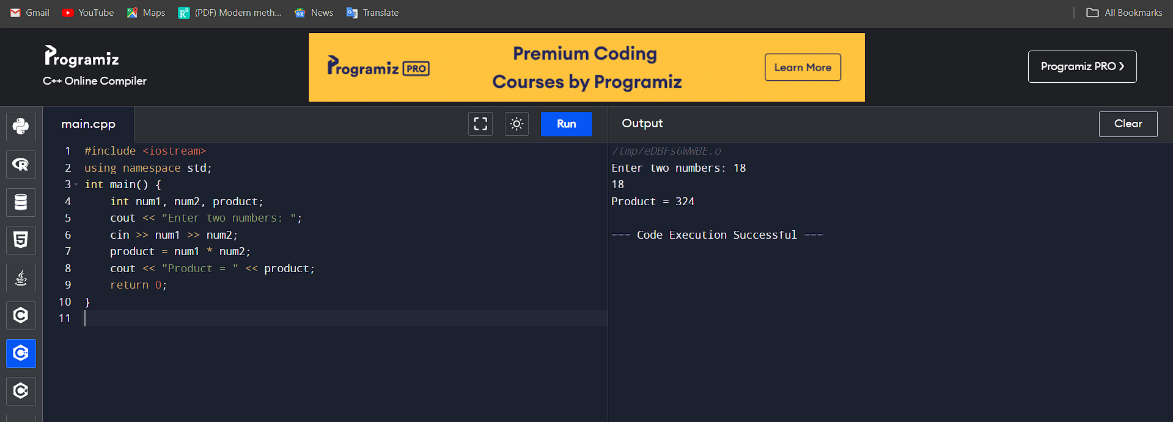

2. Write a C++ Program to Check Whether a Number is Palindrome or Not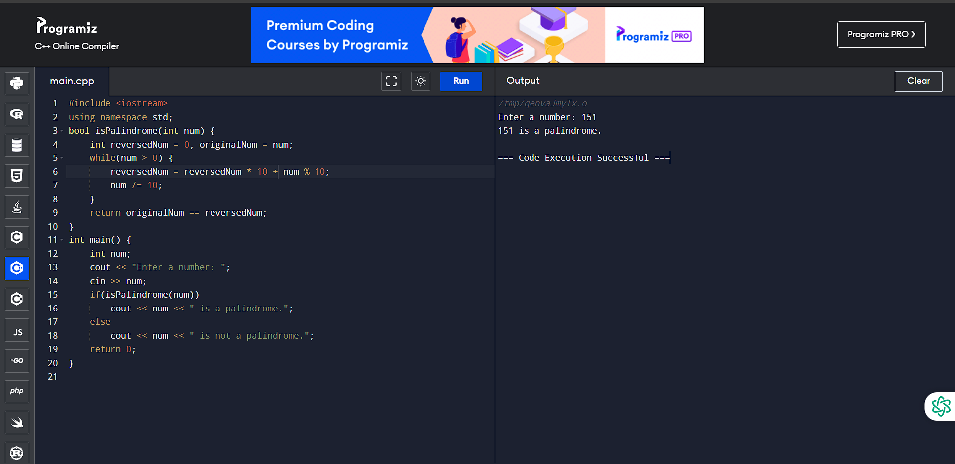

3. Write a C++ Program to Check Whether a Number is Prime or Not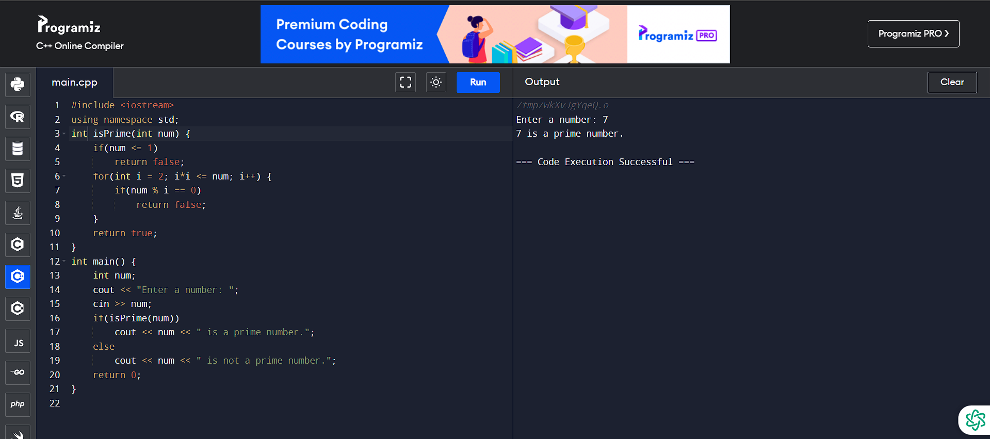

4. Write a C++ Program to Display Prime Numbers Between Two Intervals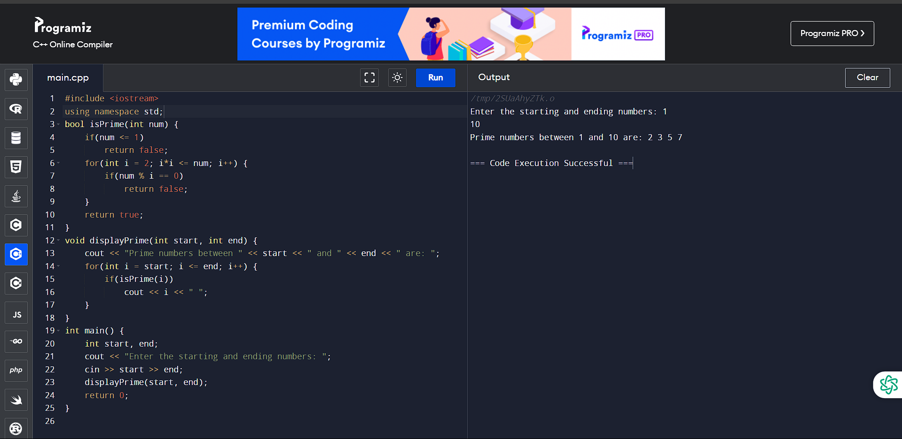

5. Write a C++ Program to Check Armstrong Number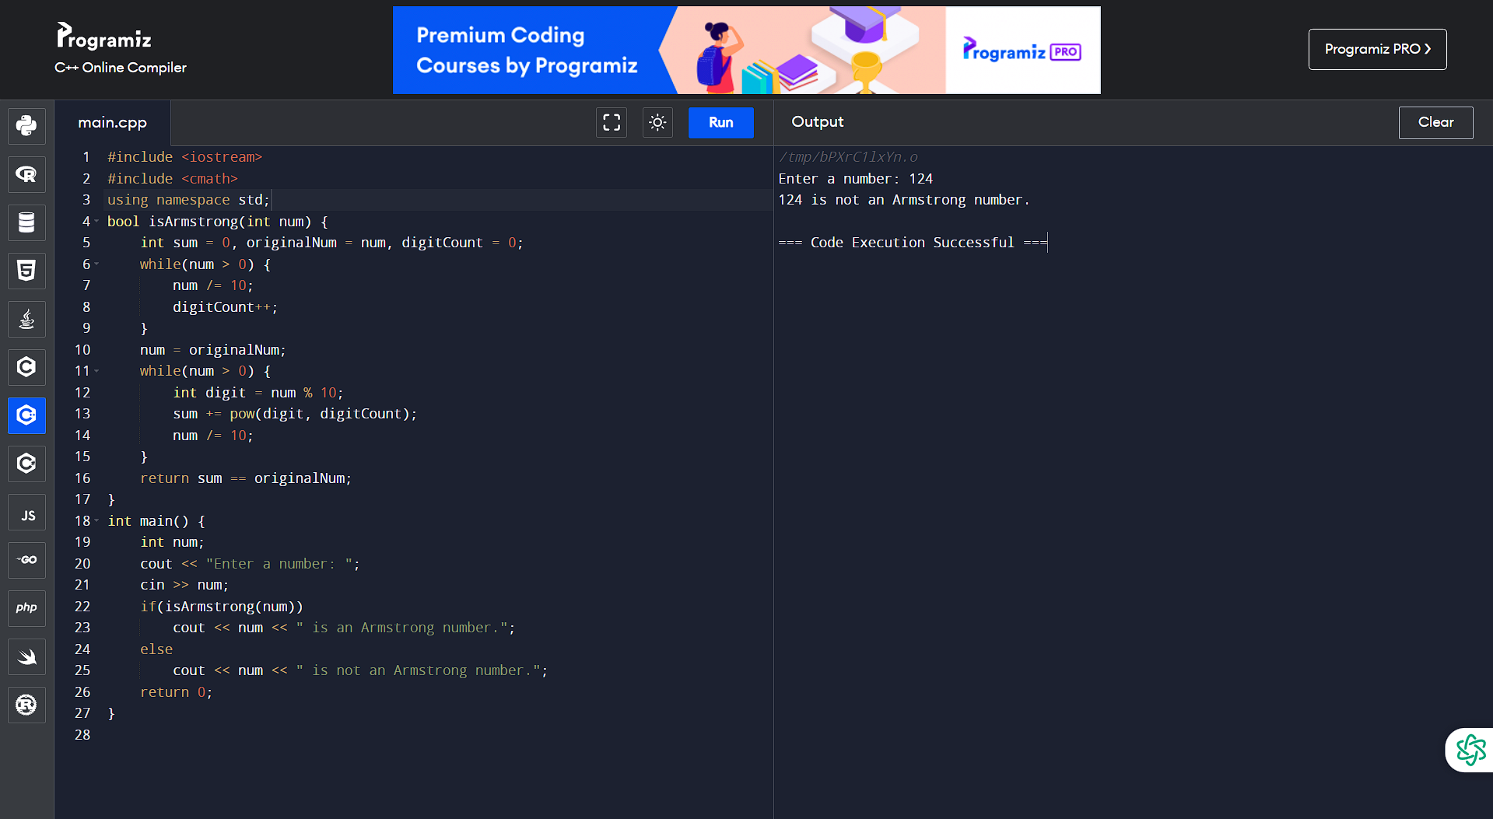

6. Write a C++ Program to Display Armstrong Number Between Two Intervals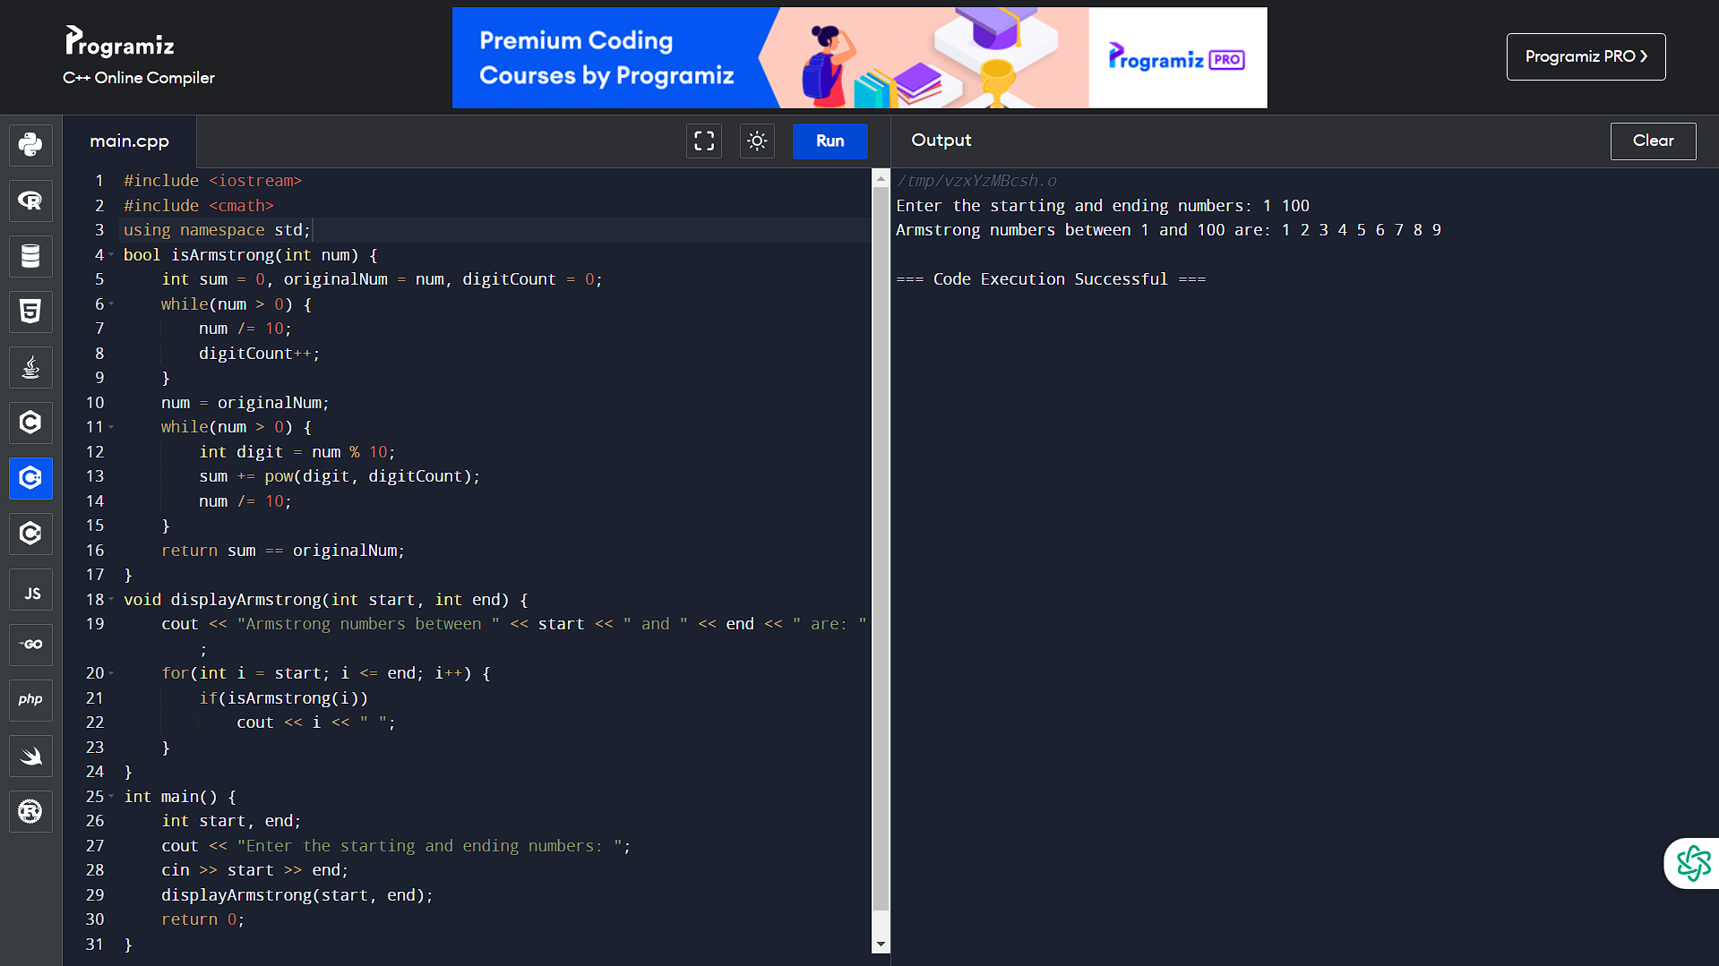

7. Write a C++ Program to Display Factors of a Number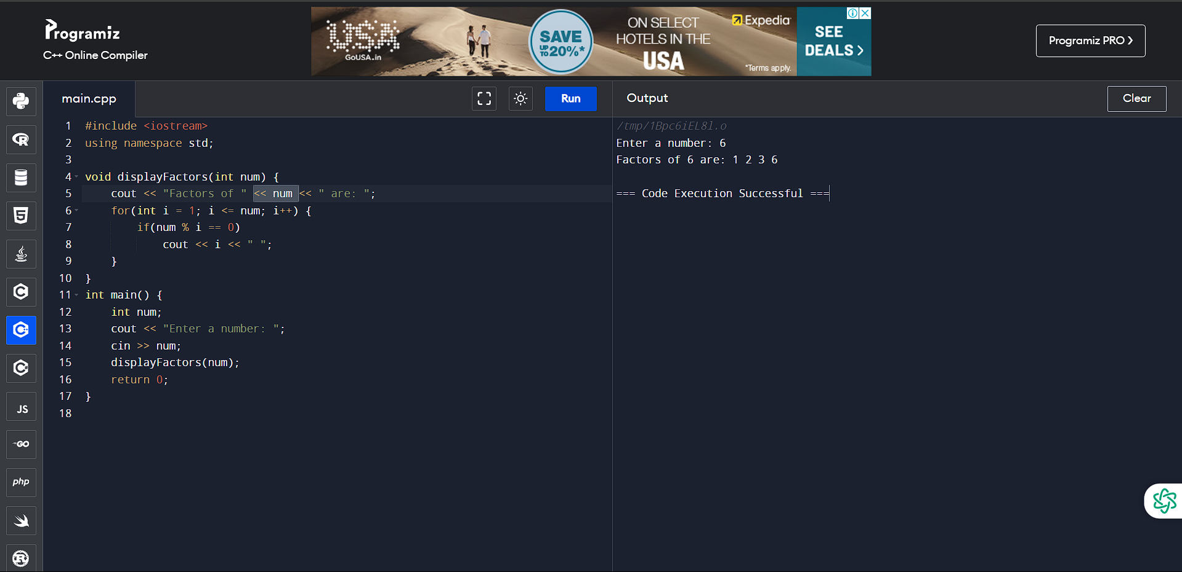

8. Write a C++ Programs To Create Pyramid and Pattern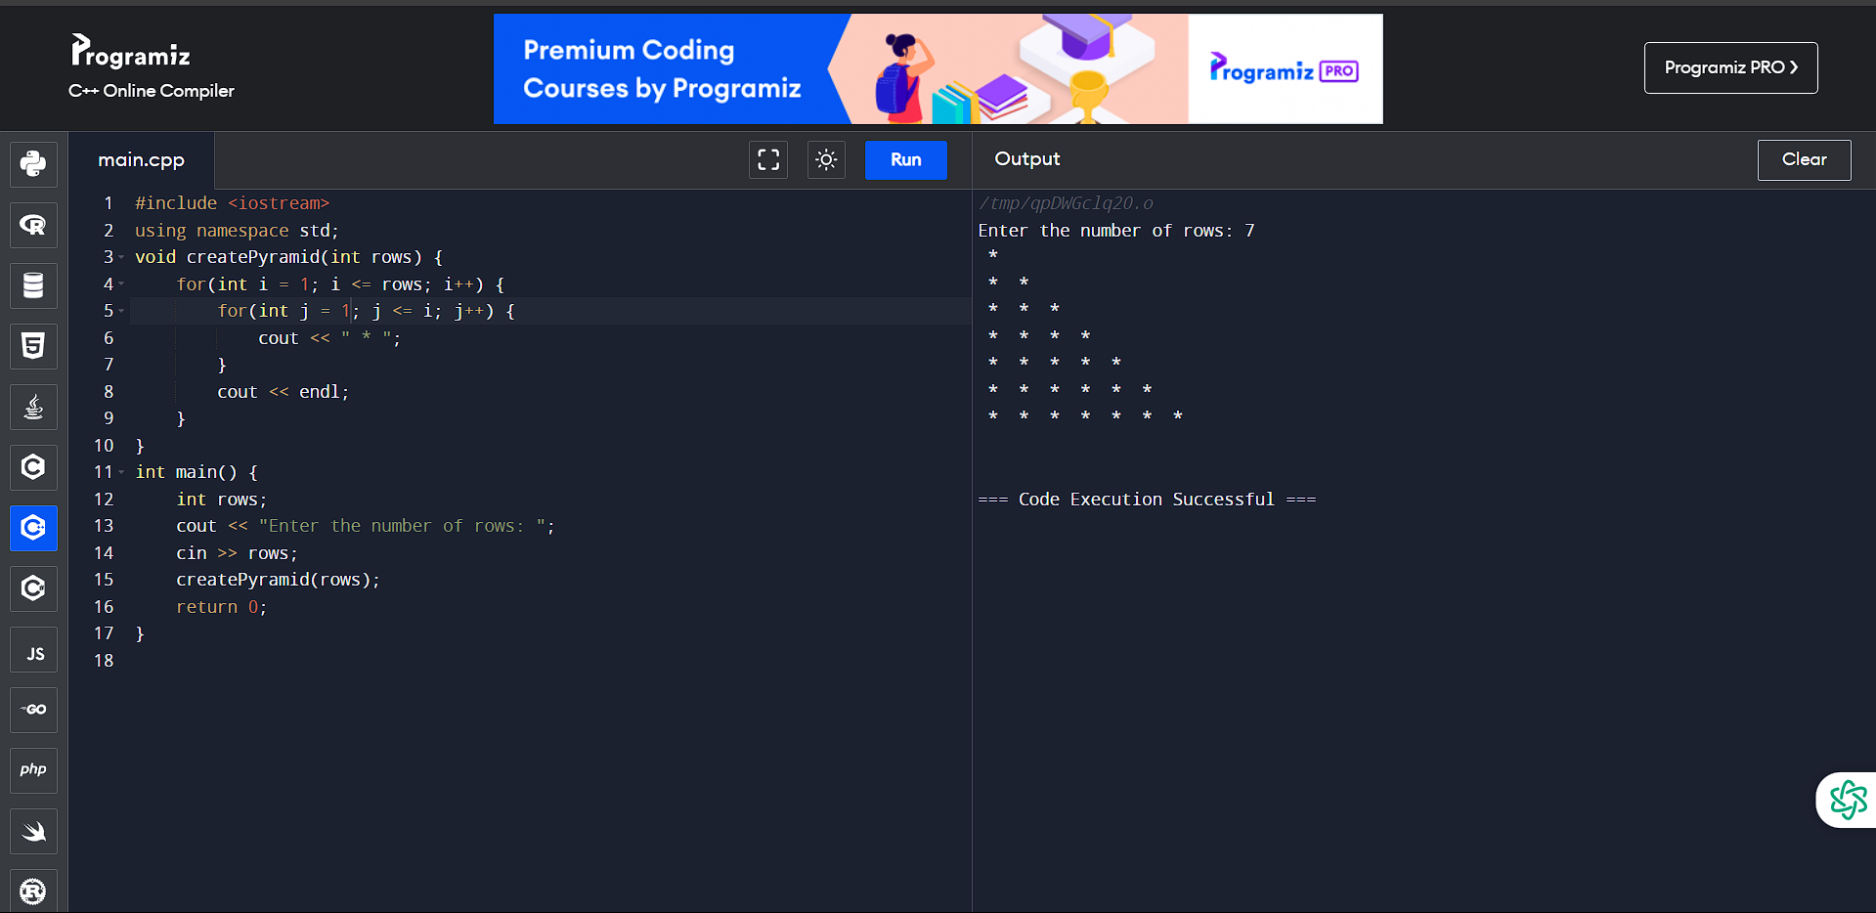

9. Write a C++ Program to Make a Simple Calculator to Add, Subtract, Multiply or Divide Using switch...case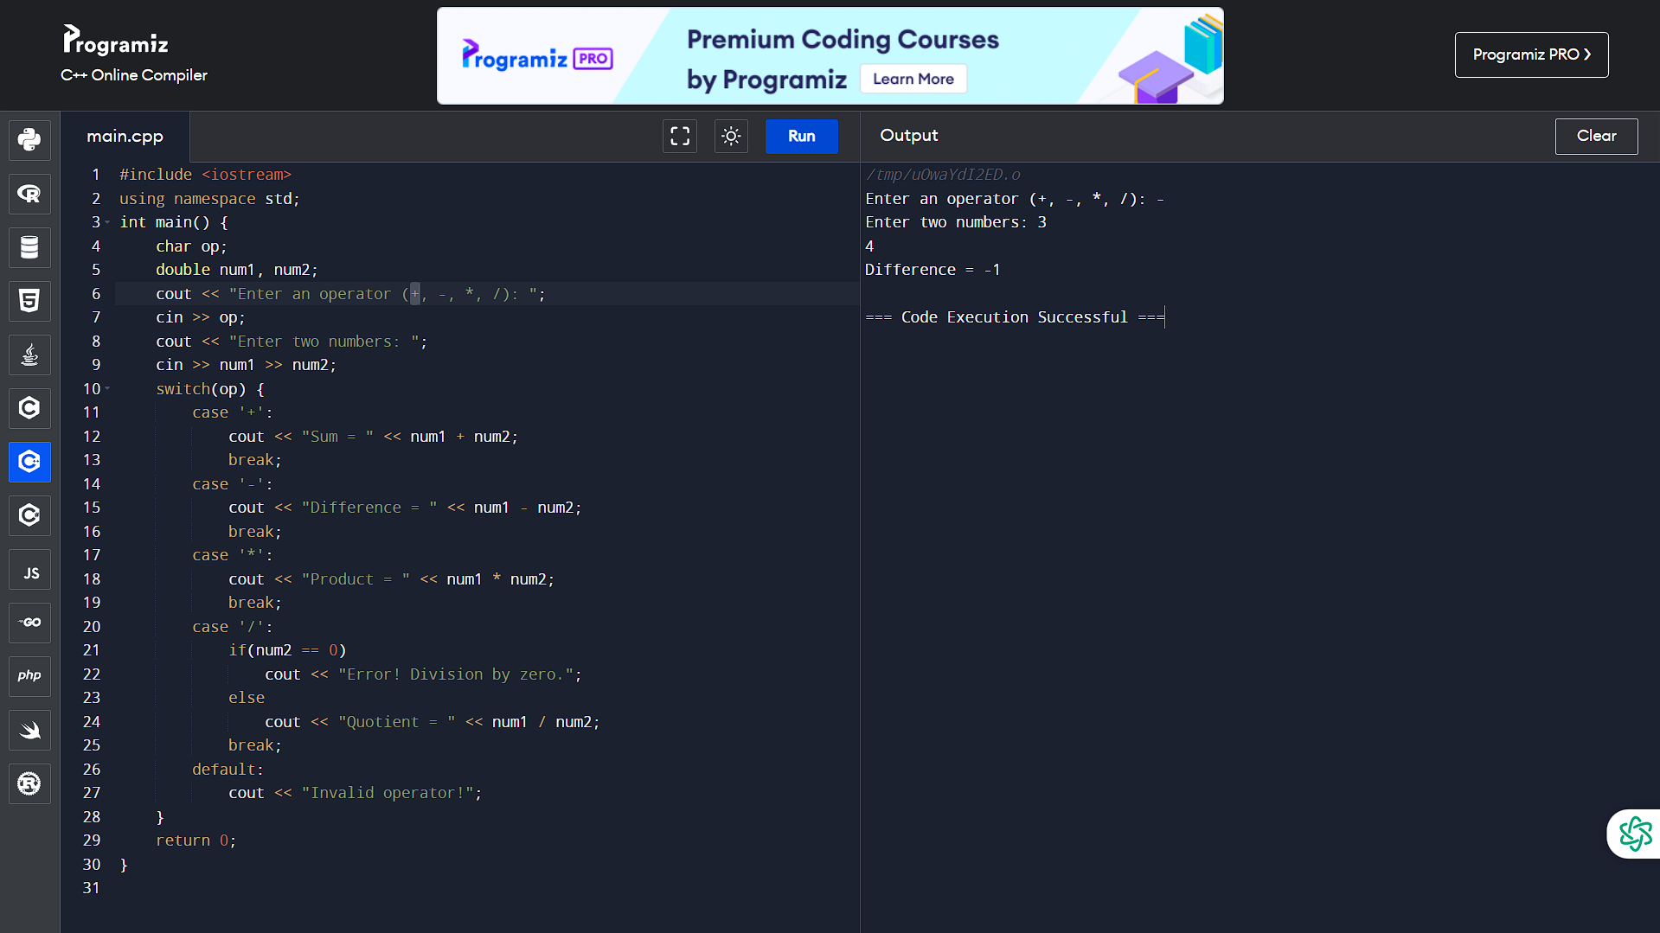

10. Write a C++ Program to Display Prime Numbers Between Two Intervals Using Functions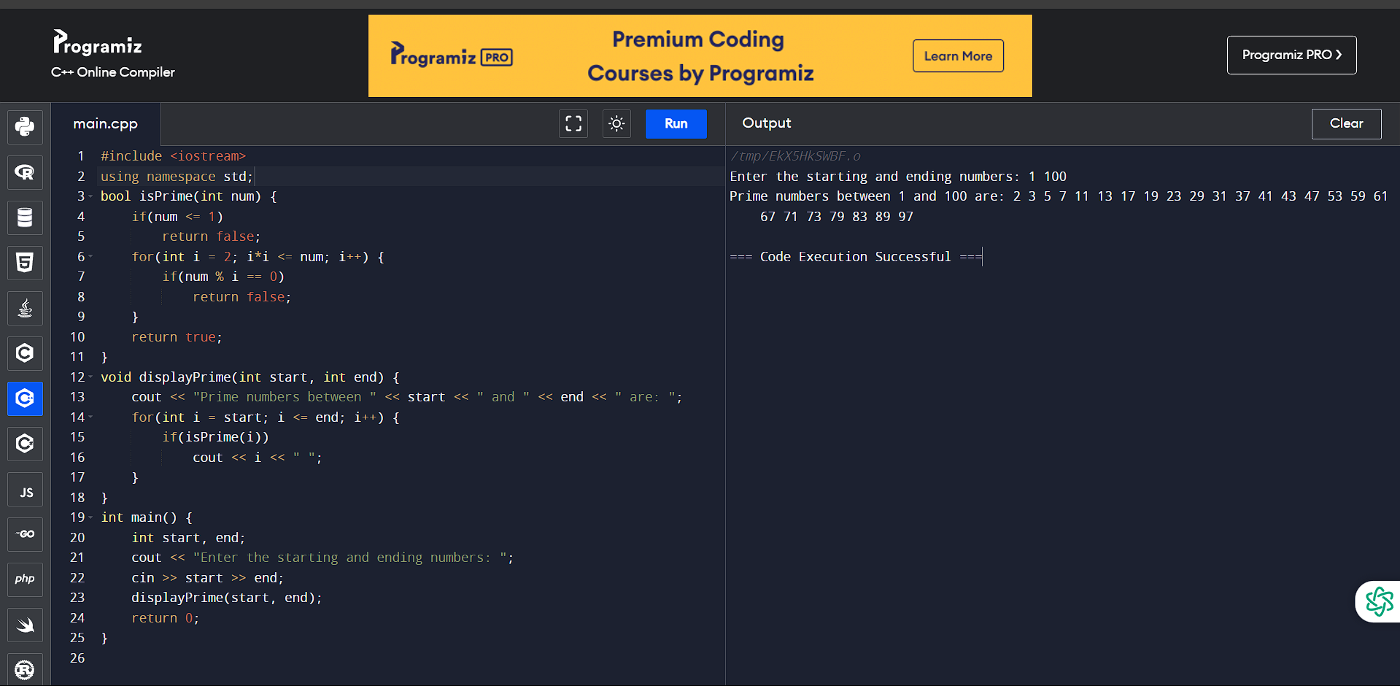

11. Write a C++ Program to Check Prime Number By Creating a Function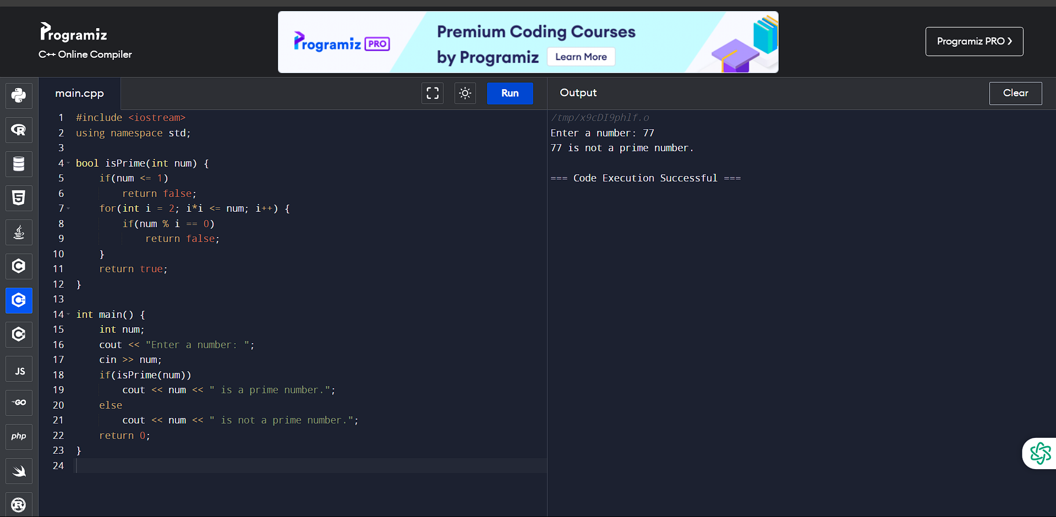

12. Write a C++ Program to Check Whether a Number can be Express as Sum of Two Prime

Numbers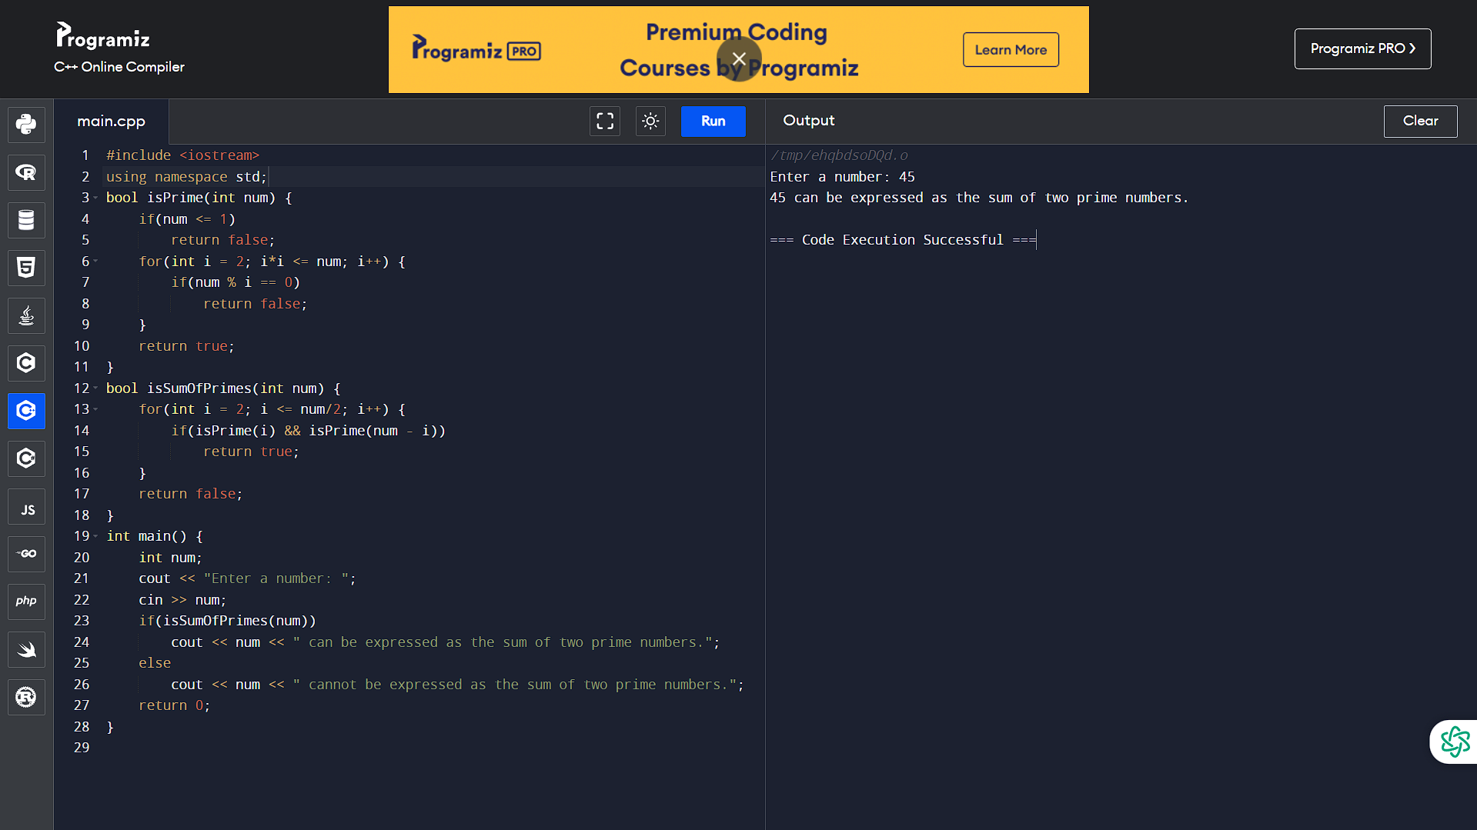

13. Write a C++ program to Find Sum of Natural Numbers using Recursion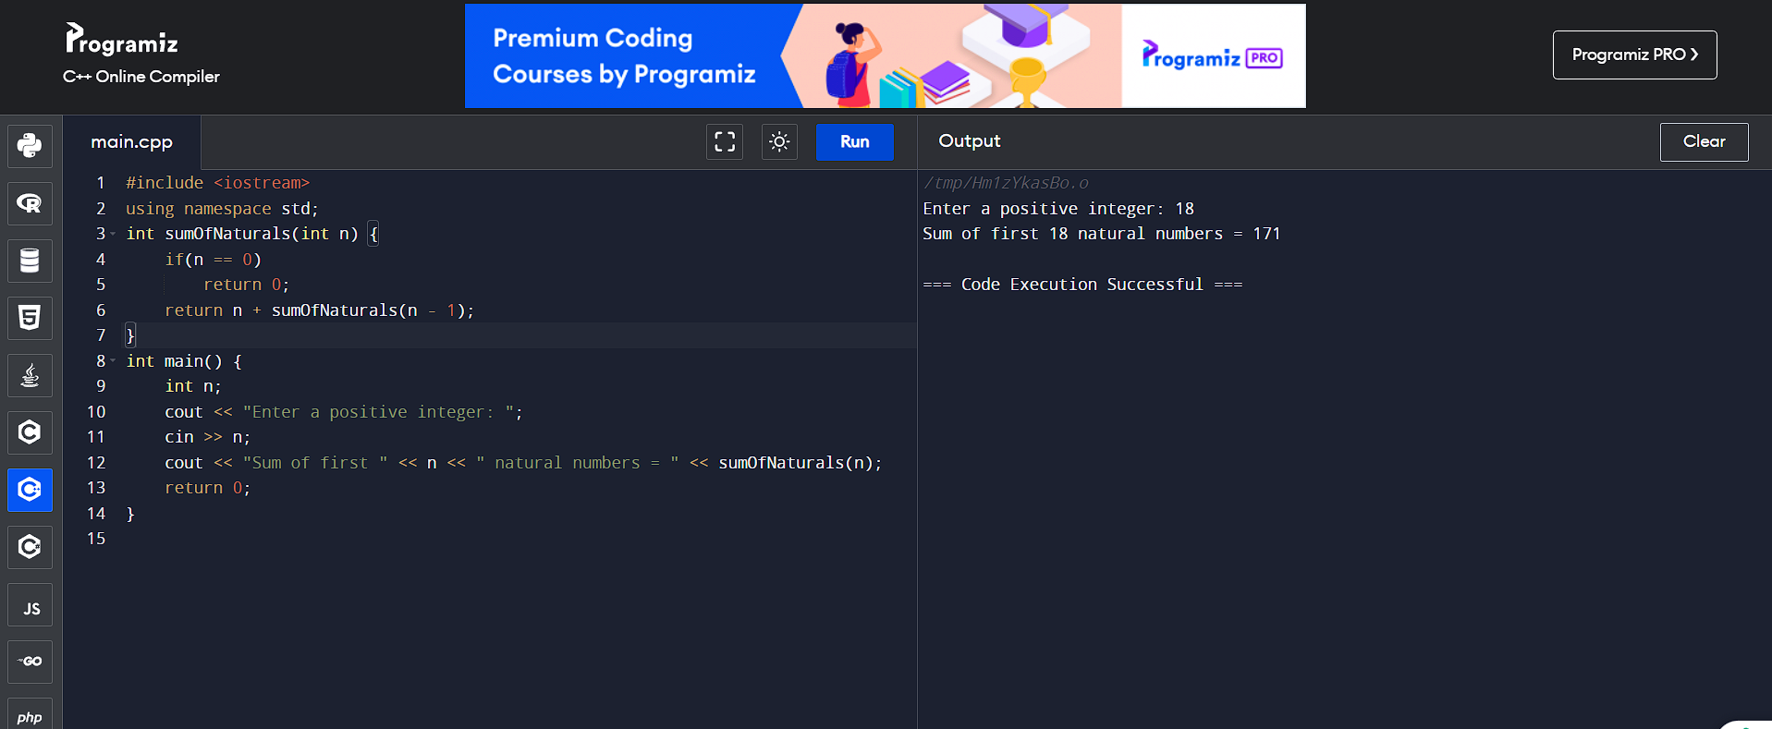

14. Write a C++ program to Calculate Factorial of a Number Using Recursion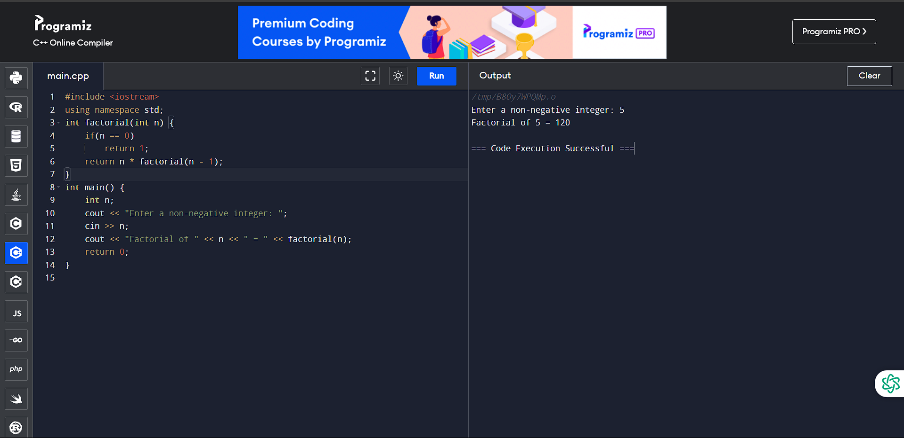

15. Write a C++ Program to Find G.C.D Using Recursion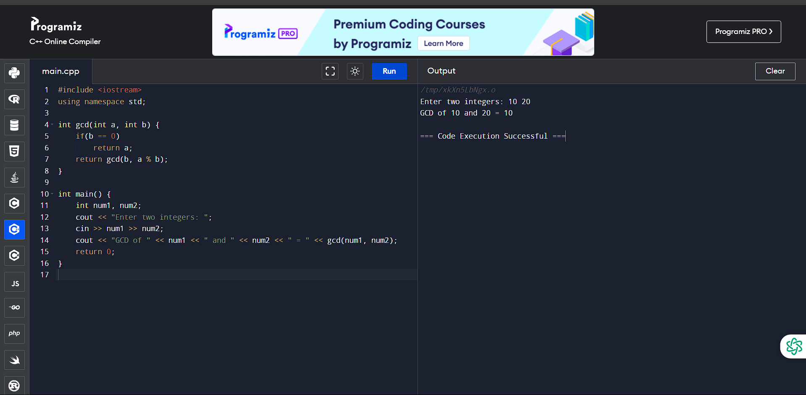

16. Write a C++ Program to Convert Binary Number to Decimal and vice-versa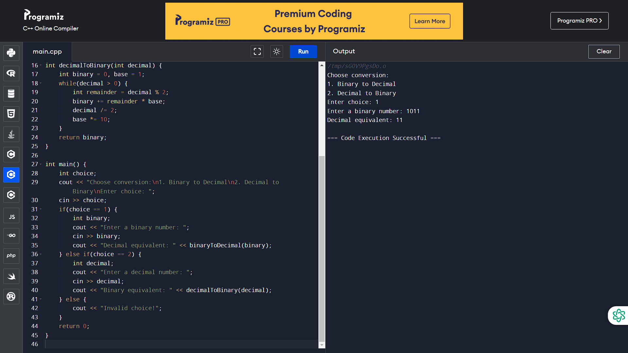

17. Write a C++ Program to Convert Octal Number to Decimal and vice-versa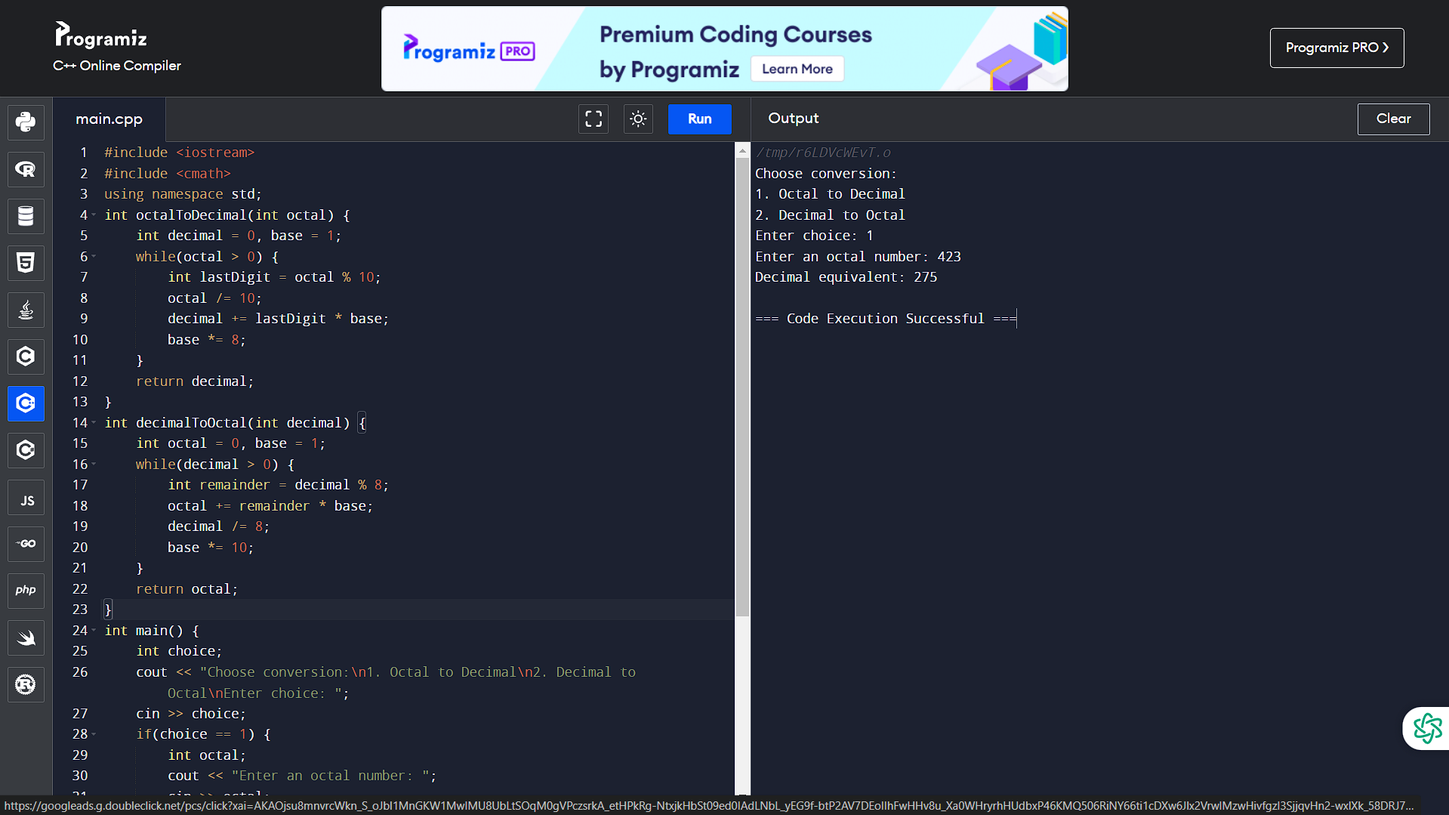

18. Write a C++ Program to Convert Binary Number to Octal and vice-versa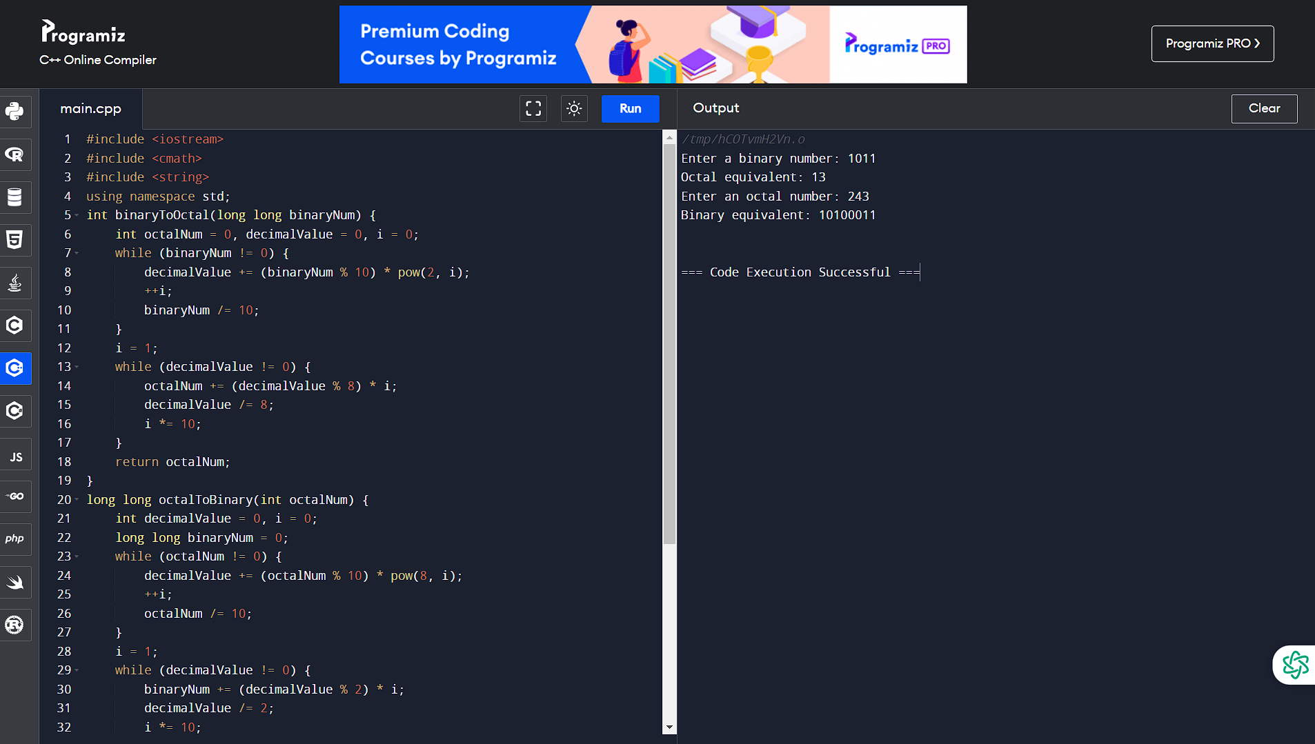

19. Write a C++ program to Reverse a Sentence Using Recursion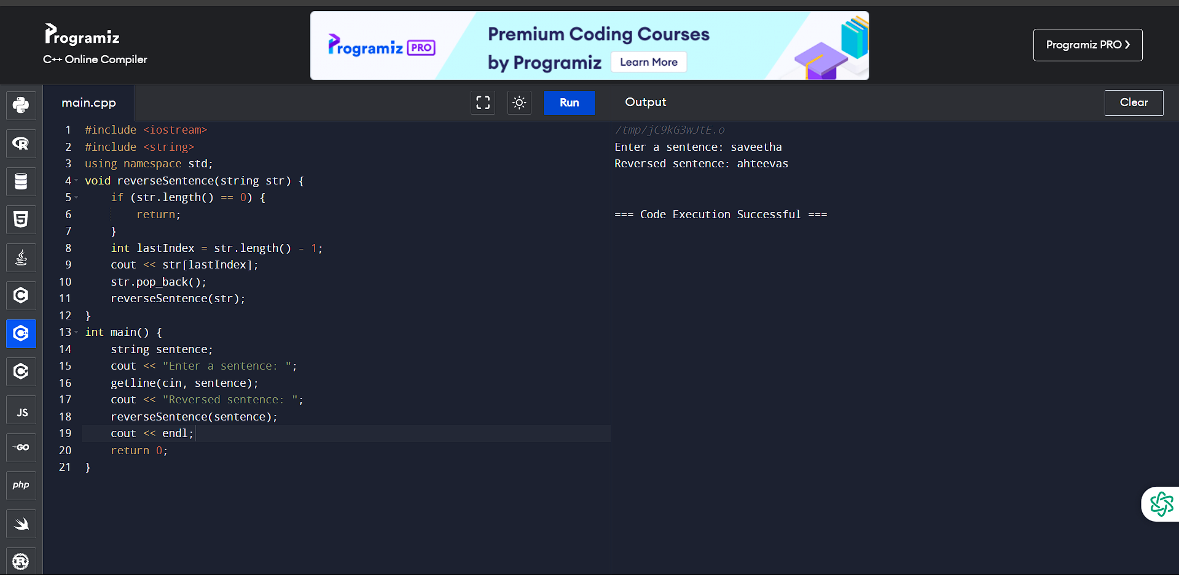

20. Write a C++ Program to Calculate Power Using Recursion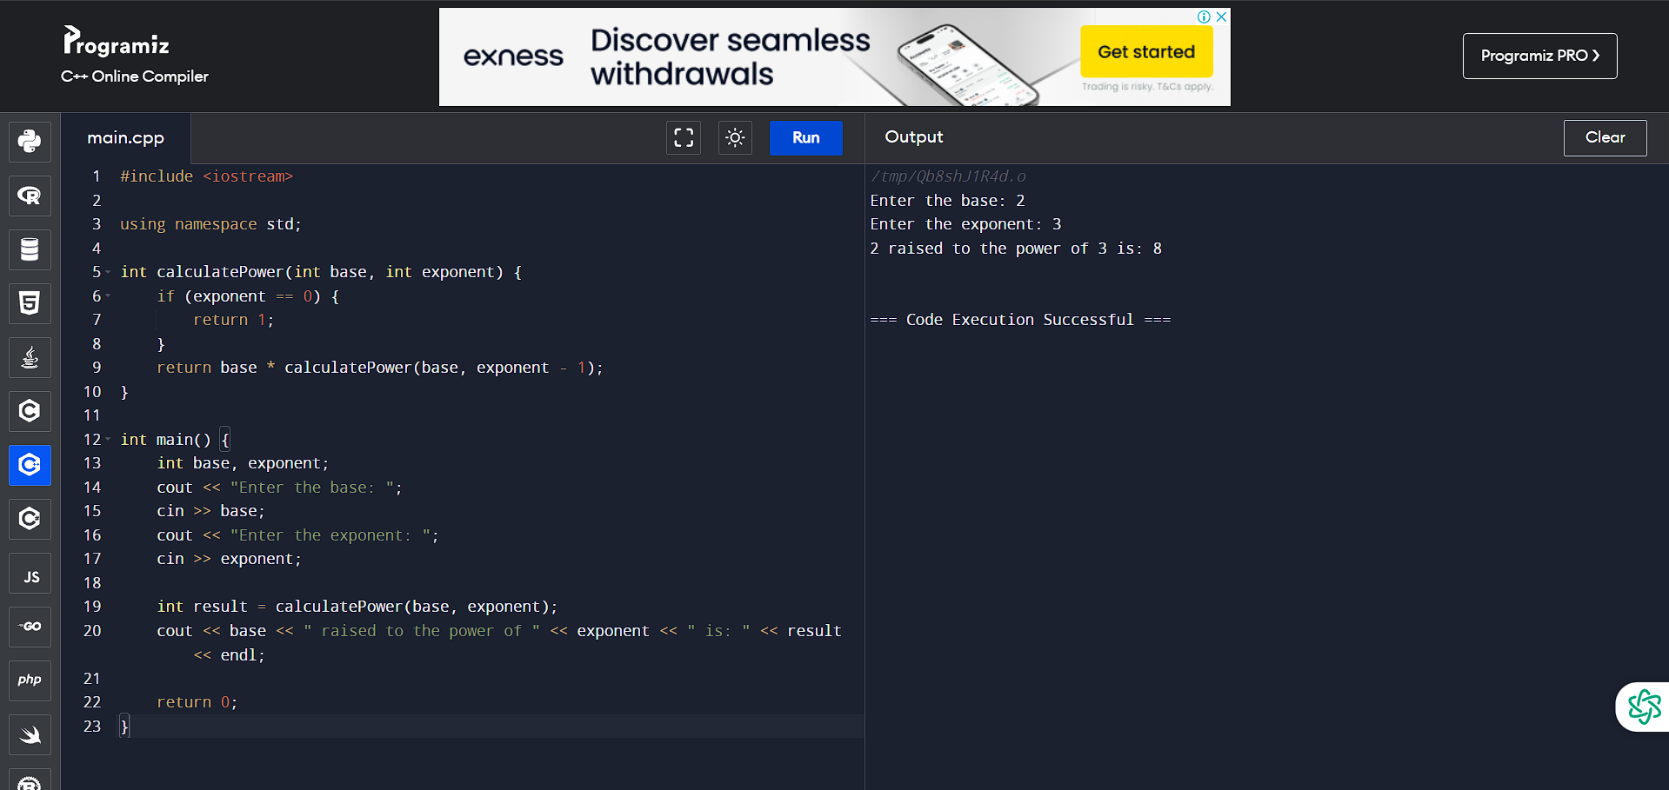

21. Write a C++ Program to Calculate Average of Numbers Using Arrays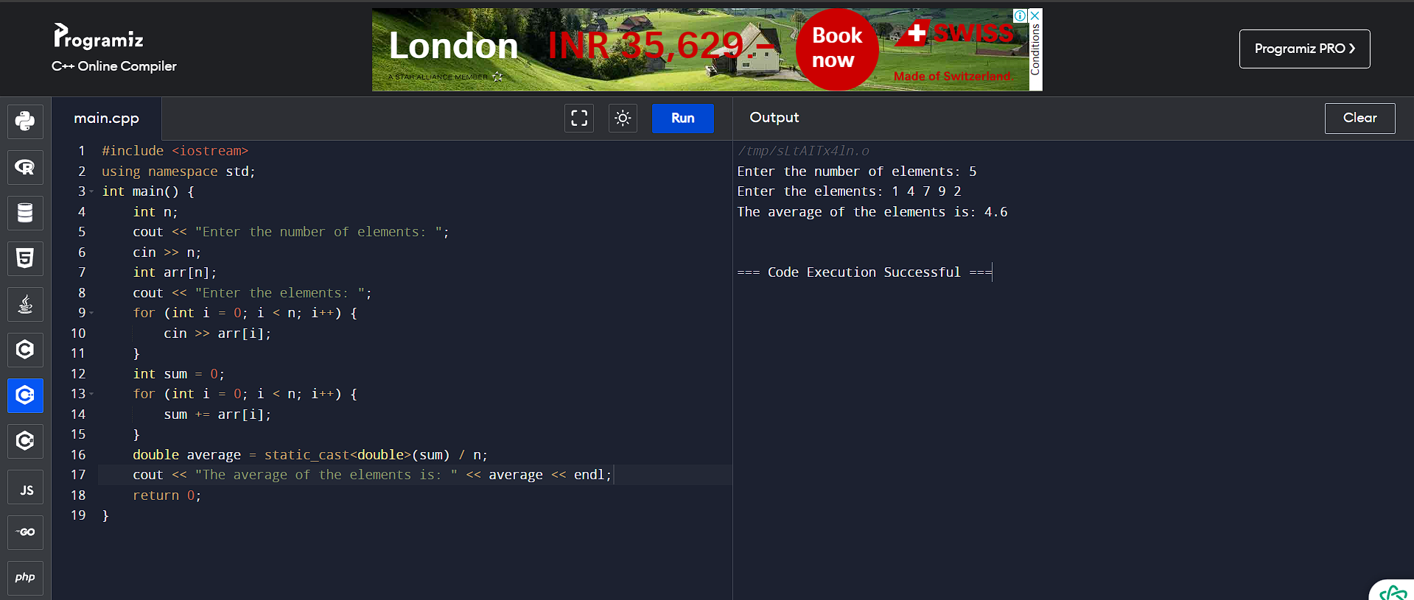

22. Write a C++ Program to Find Largest Element of an Array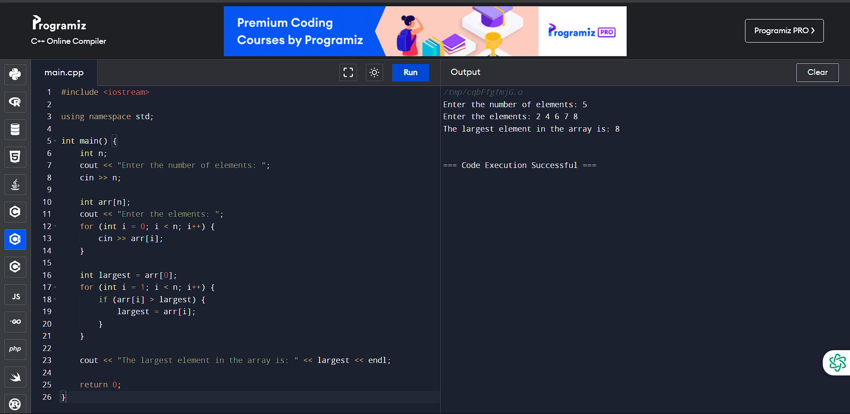

23. Write a C++ Program to Calculate Standard Deviation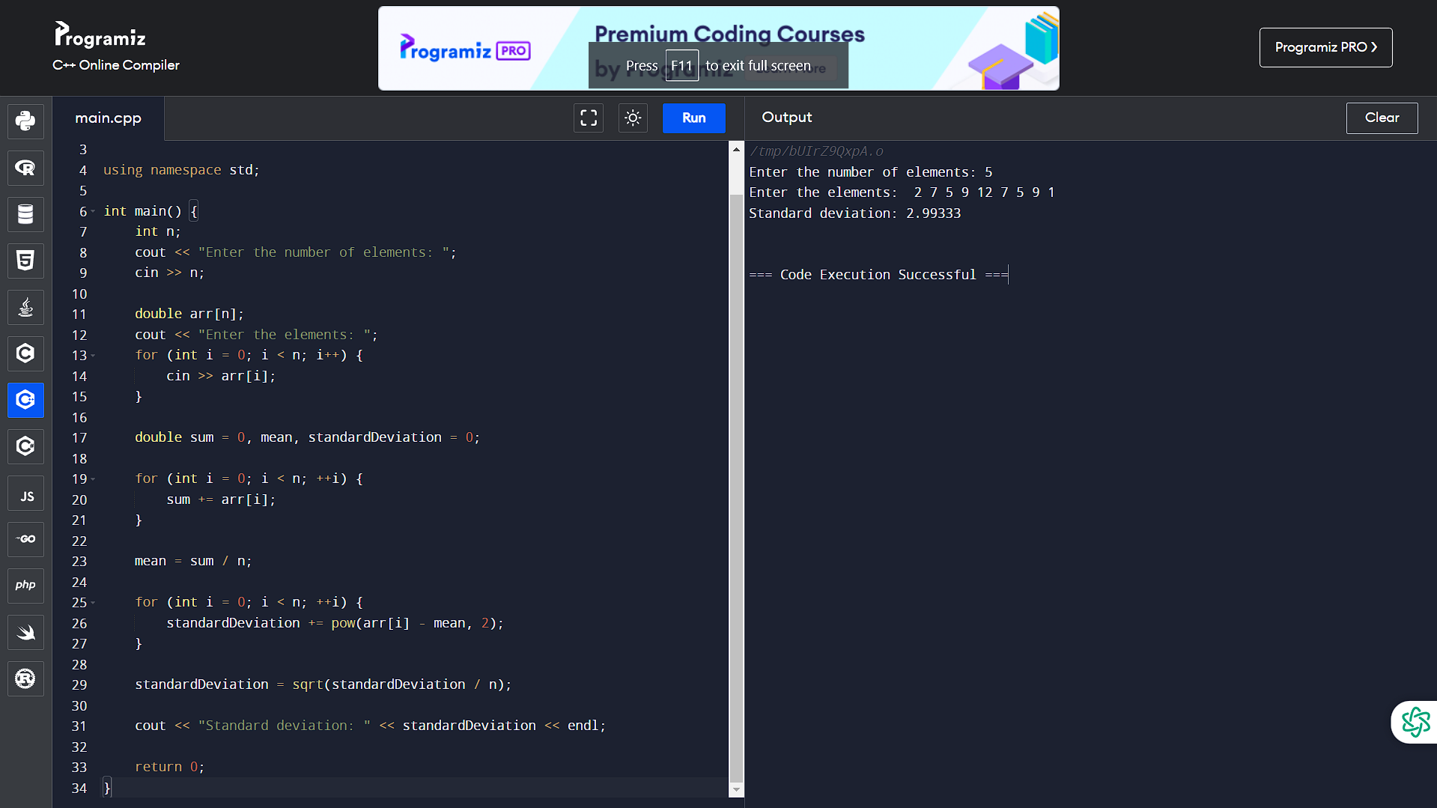

24. Write a C++ Program to Add Two Matrix Using Multi-Dimensional Arrays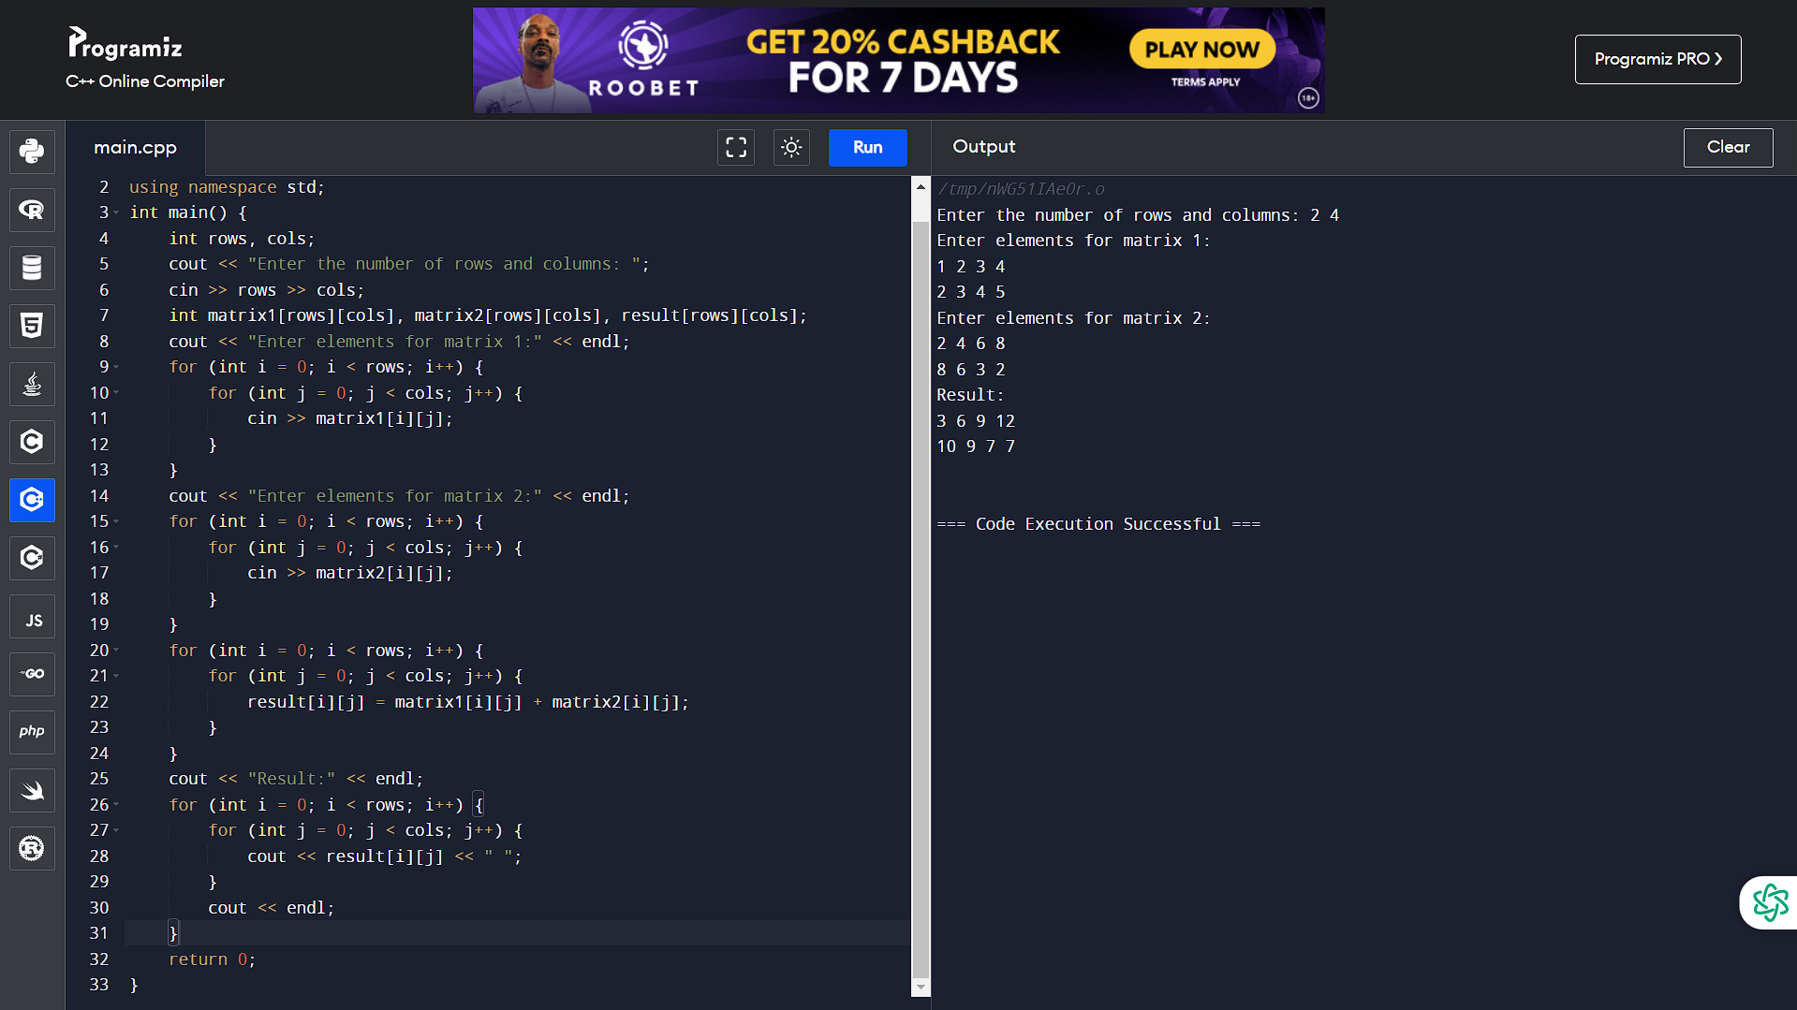

25. Write a C++ Program to Multiply Two Matrix Using Multi-Dimensional Arrays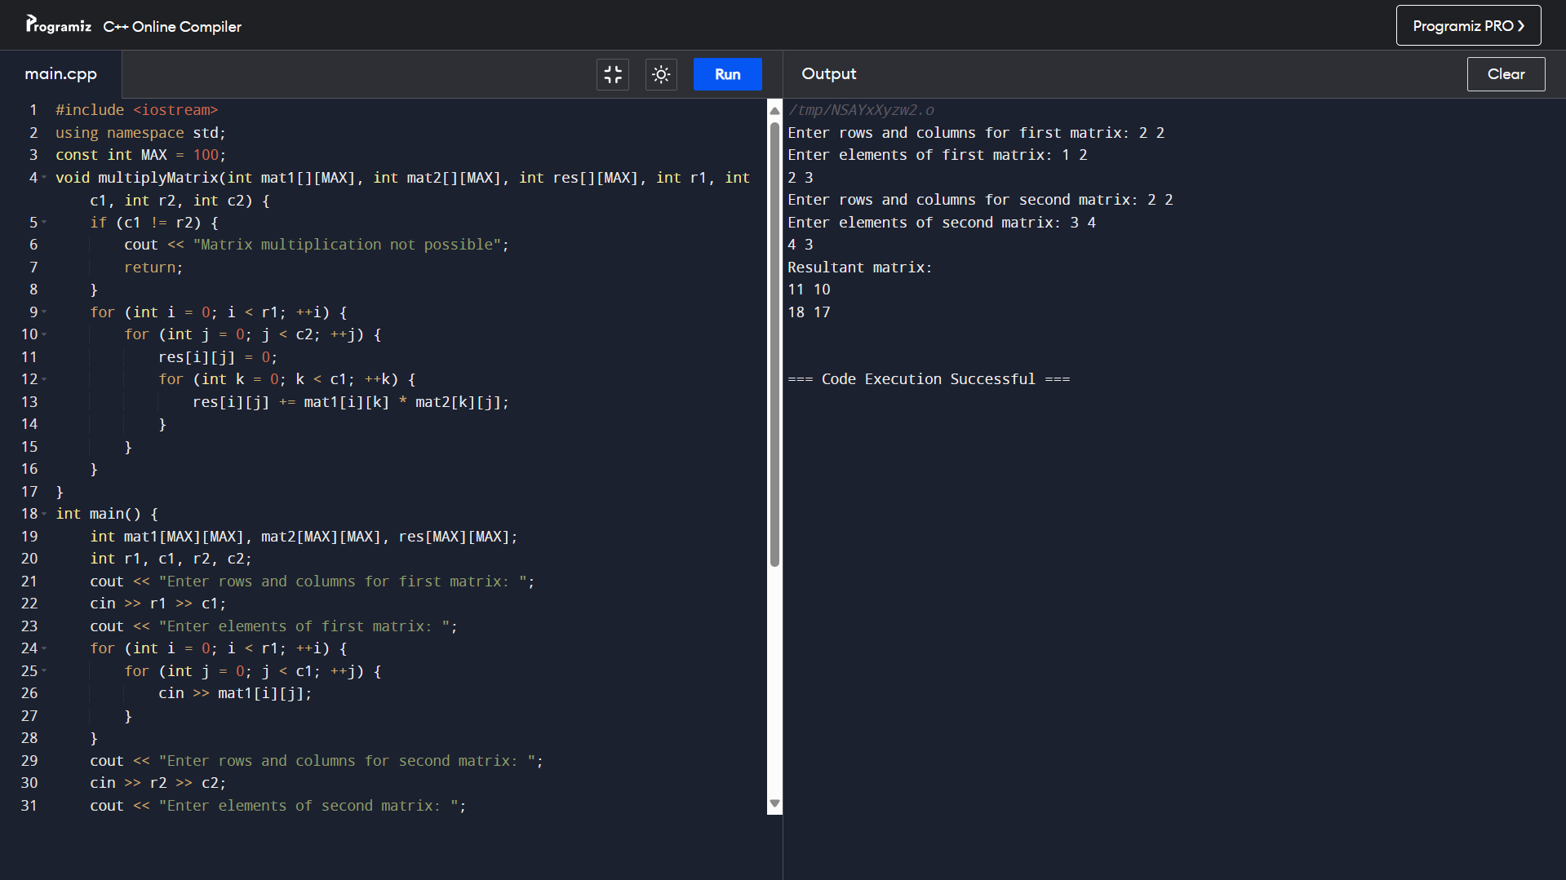

26. Write a C++ Program to Find Transpose of a Matrix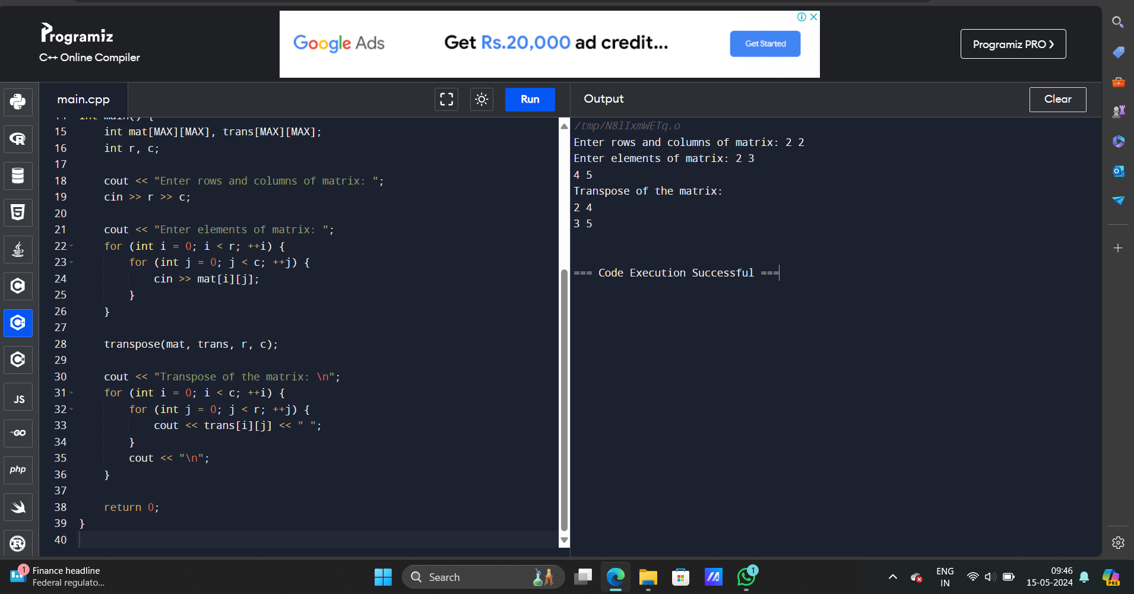

27. Write a C++ Program to Multiply two Matrices by Passing Matrix to Function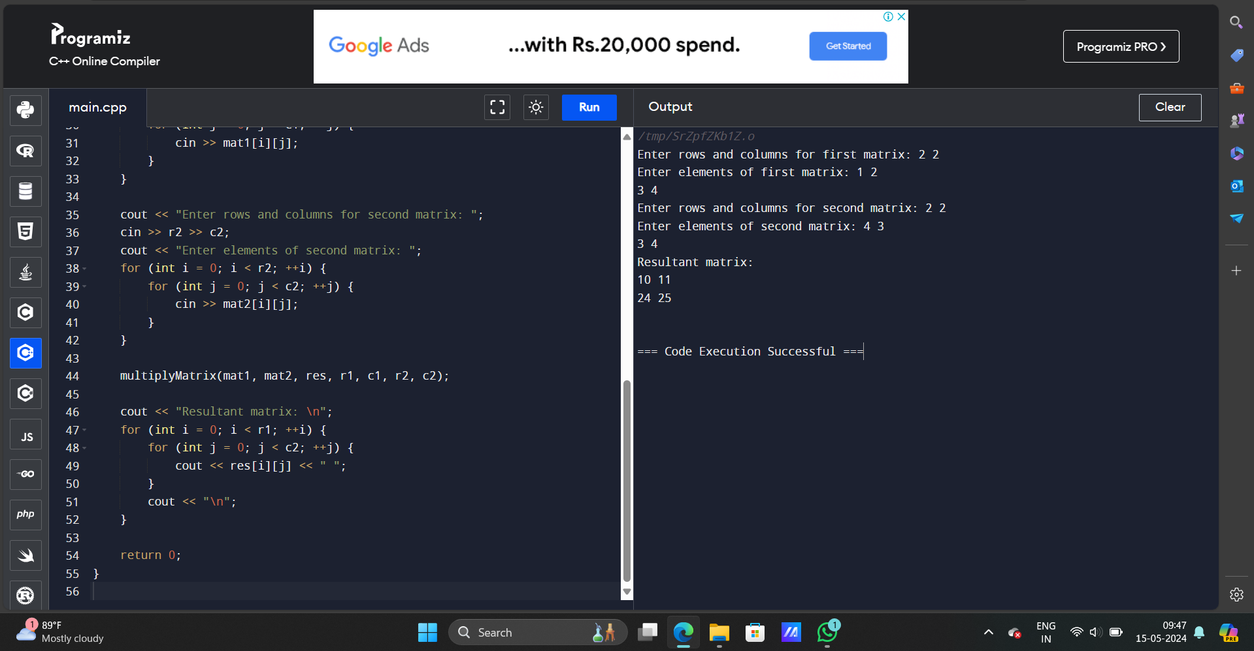

28. Write a C++ Program to Access Elements of an Array Using Pointer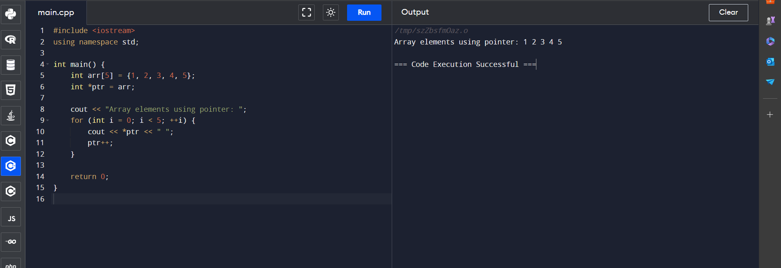

29. Write a C++ Program to Swap Numbers in Cyclic Order Using Call by Reference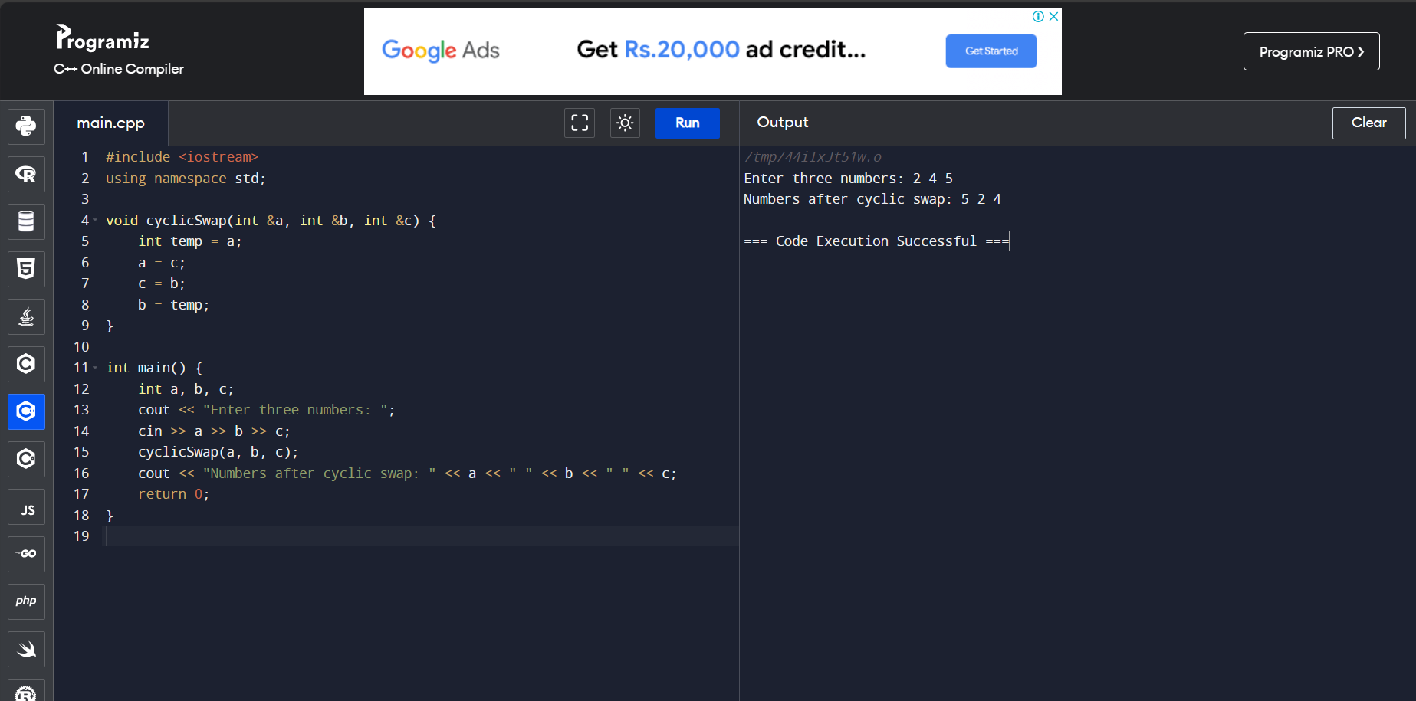

30. Write a C++ Program to Find the Frequency of Characters in a String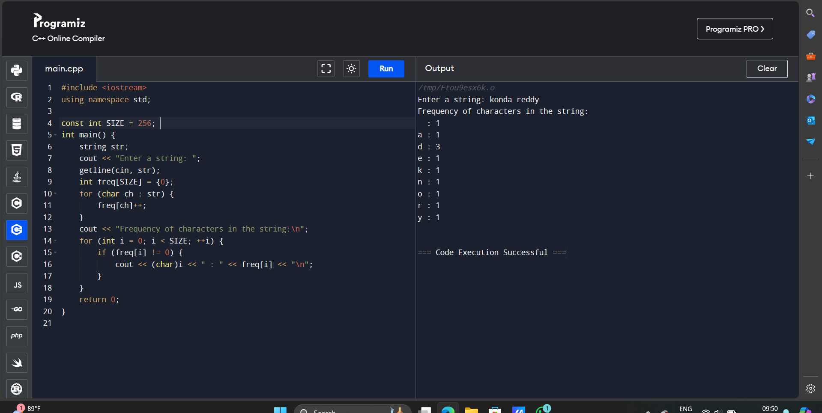

31. Write a C++ Program to Find the Number of Vowels, Consonants, Digits and White Spaces in a String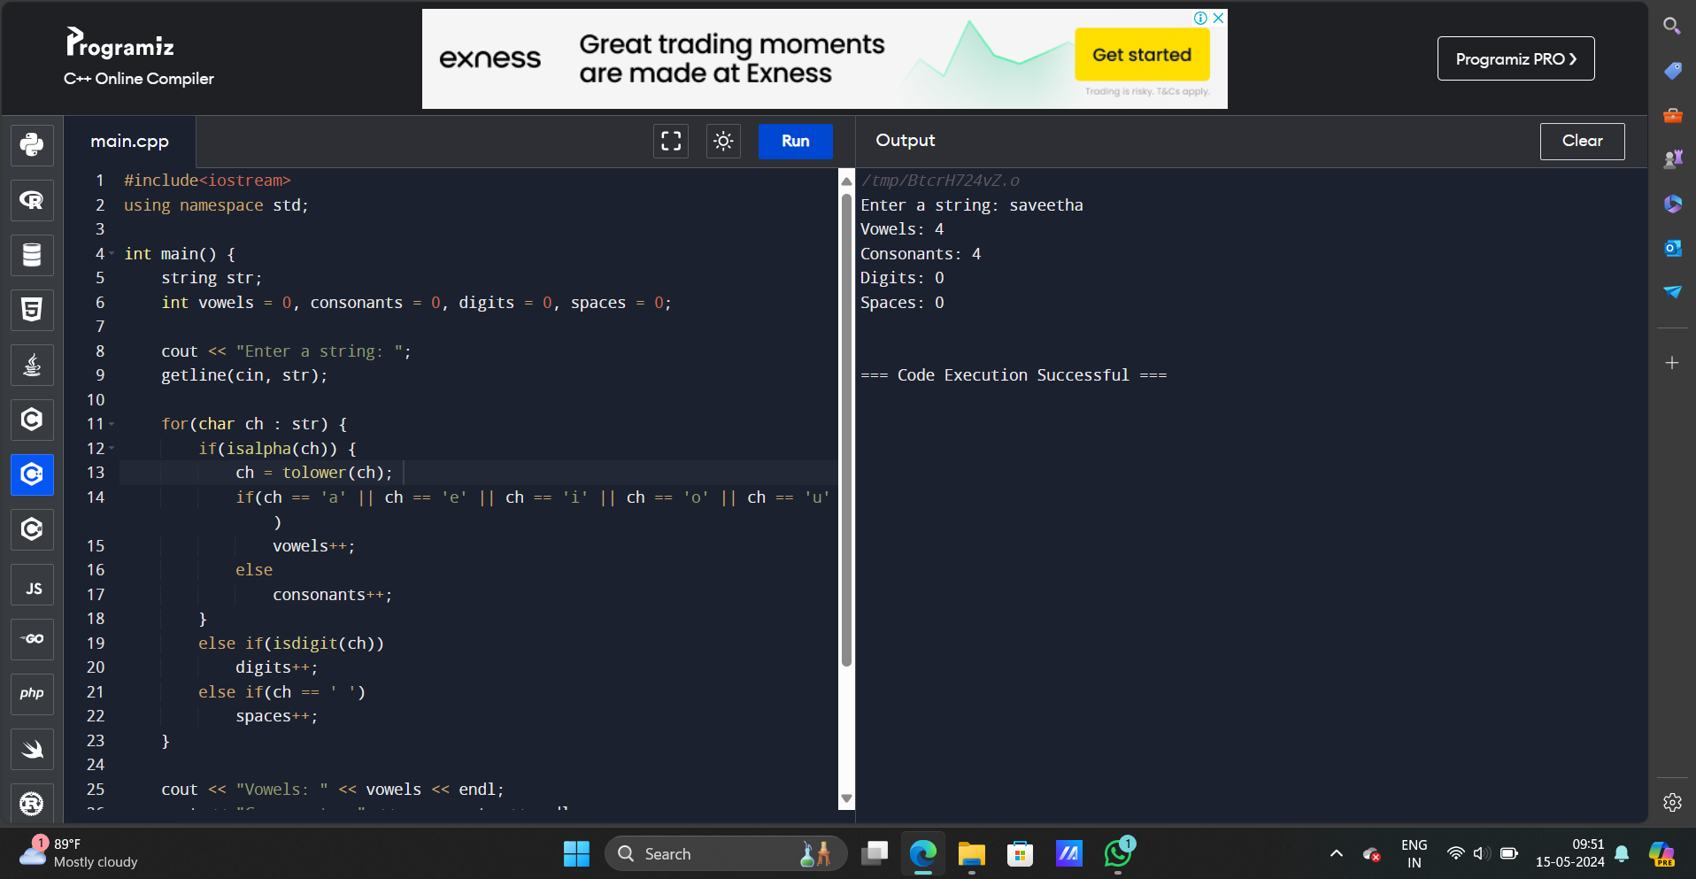

32. Write a C++ Program to Remove all Characters in a String Except Alphabets.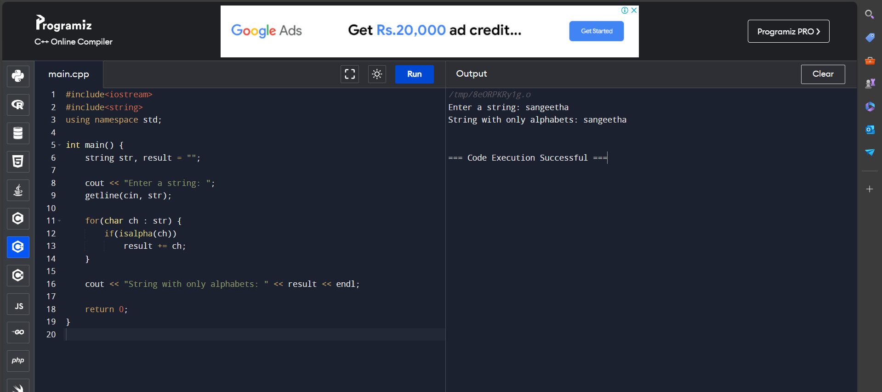

33. Write a C++ Program to Find the Length of a String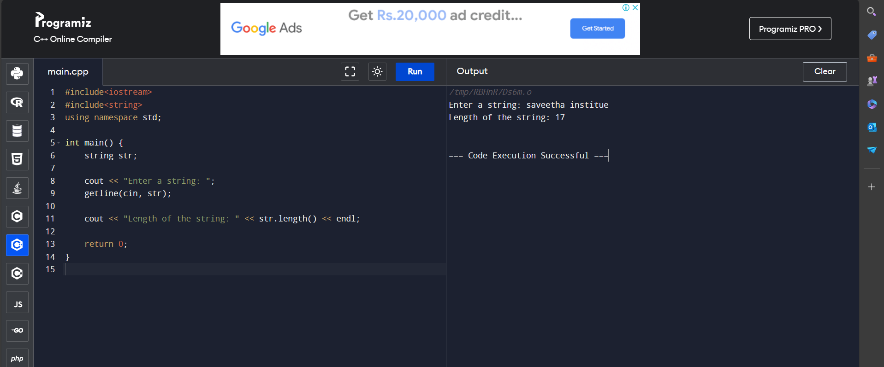

34. Write a C++ Program to Concatenate Two Strings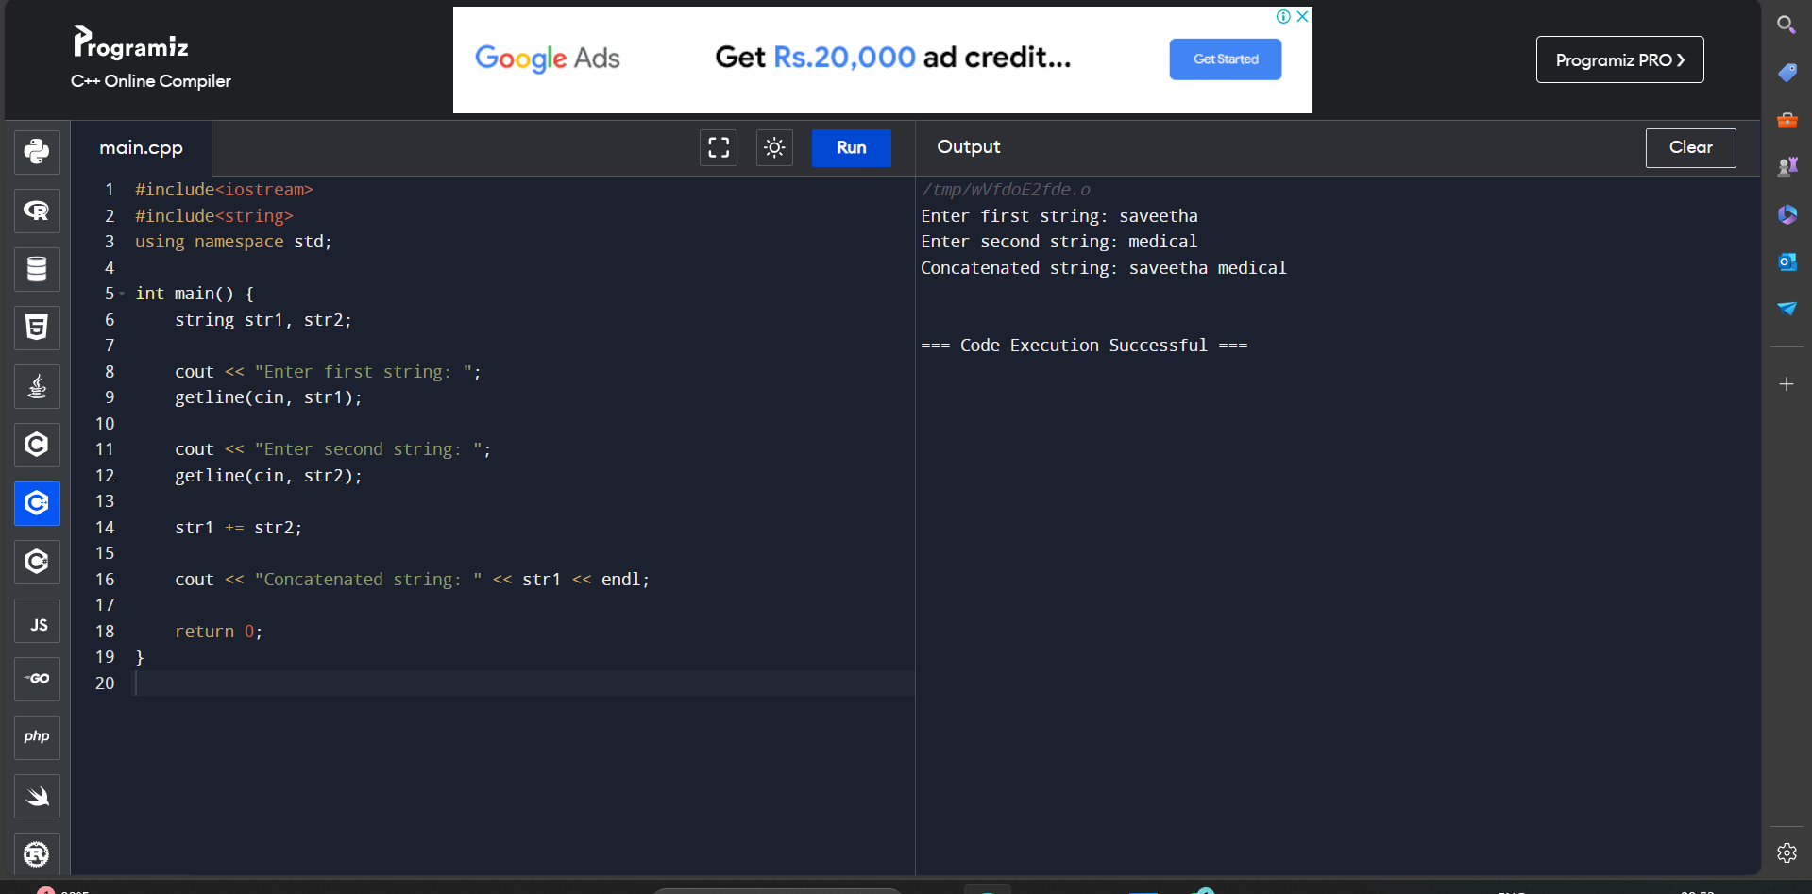

35. Write a C++ Program to Copy Strings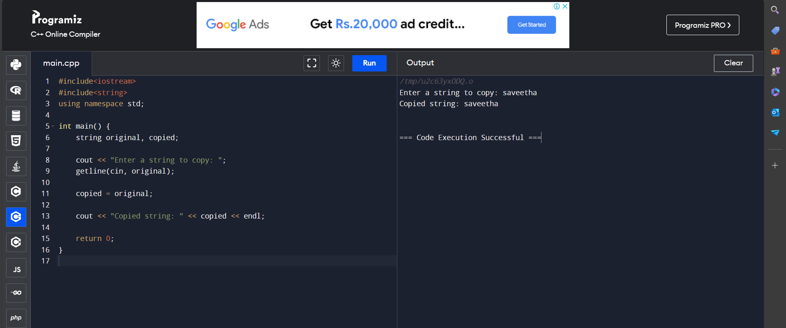

36. Write a C++ Program to Sort Elements in Lexicographical Order (Dictionary Order)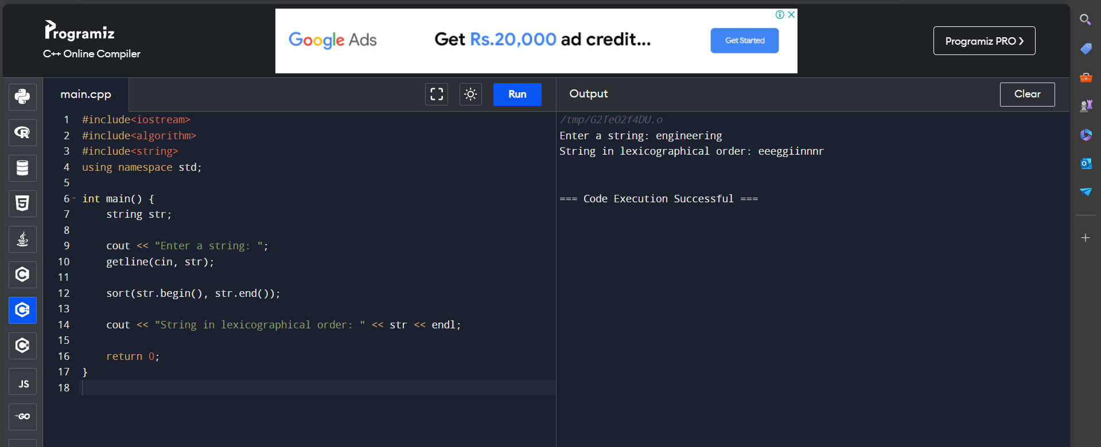

37. Write a C++ Program to Store Information of a Student in a Structure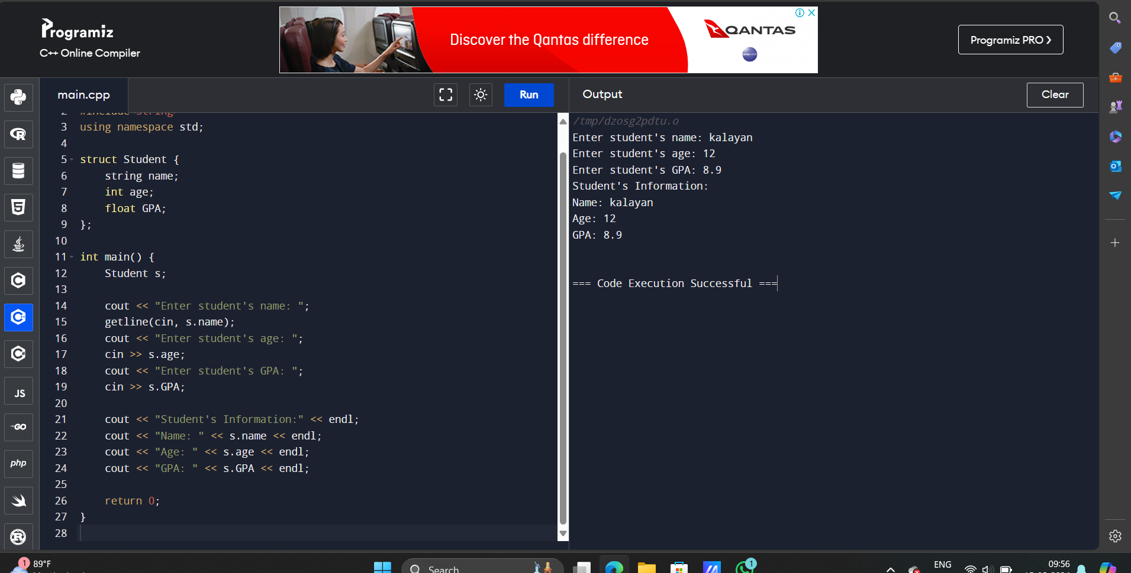

38. Write a C++ Program to Add Two Distances (in inch-feet) System Using Structures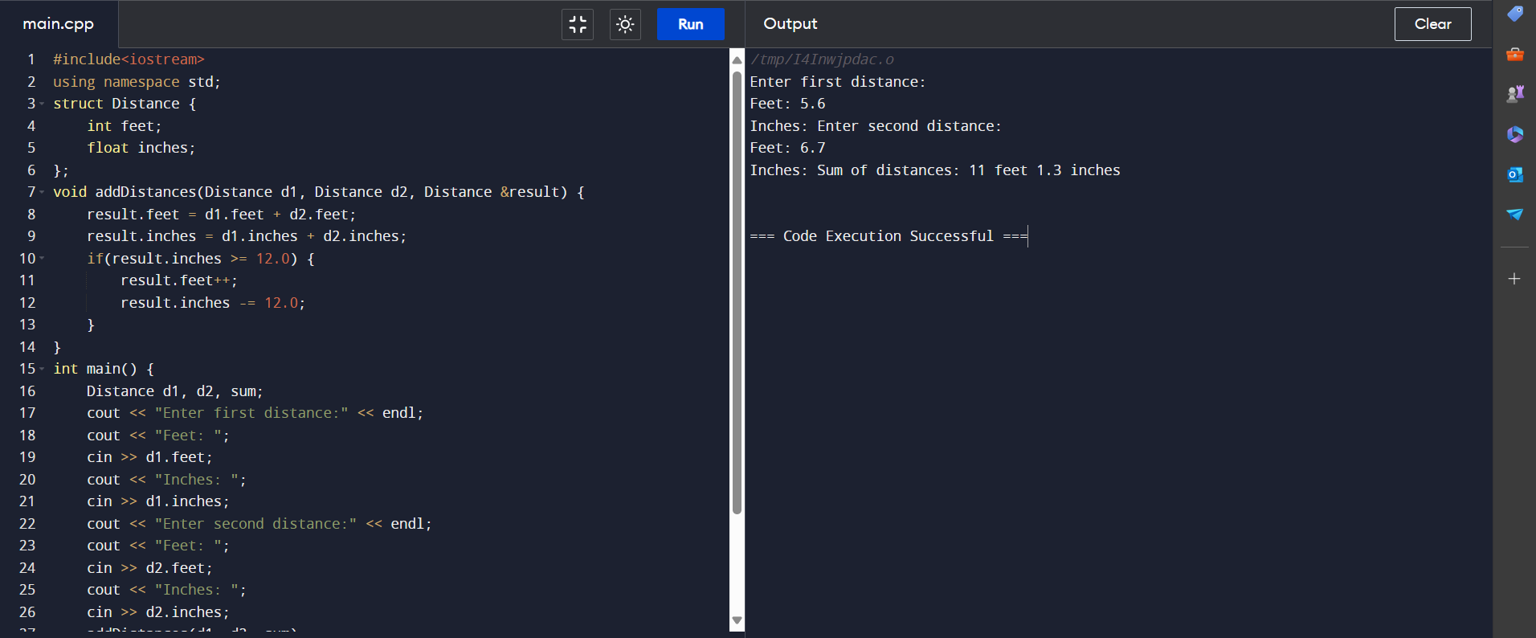

39. Write a C++ Program to Add Complex Numbers by Passing Structure to a Function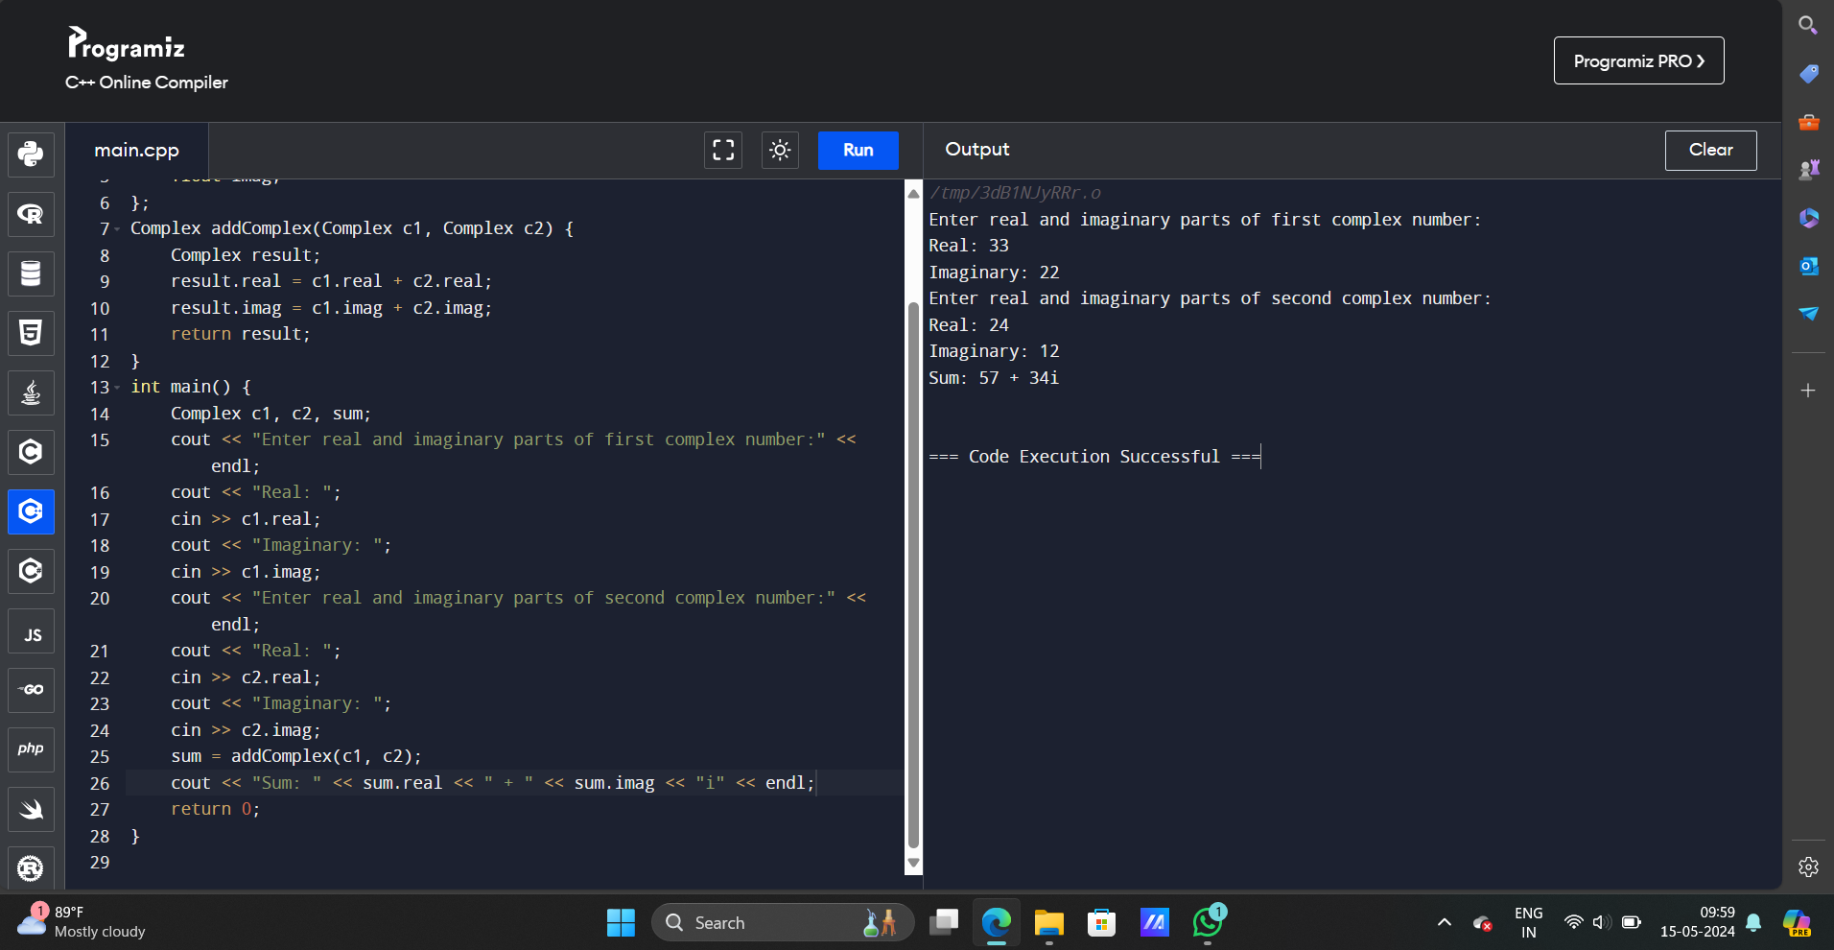

40. Write a C++ Program to Calculate Difference Between Two Time Period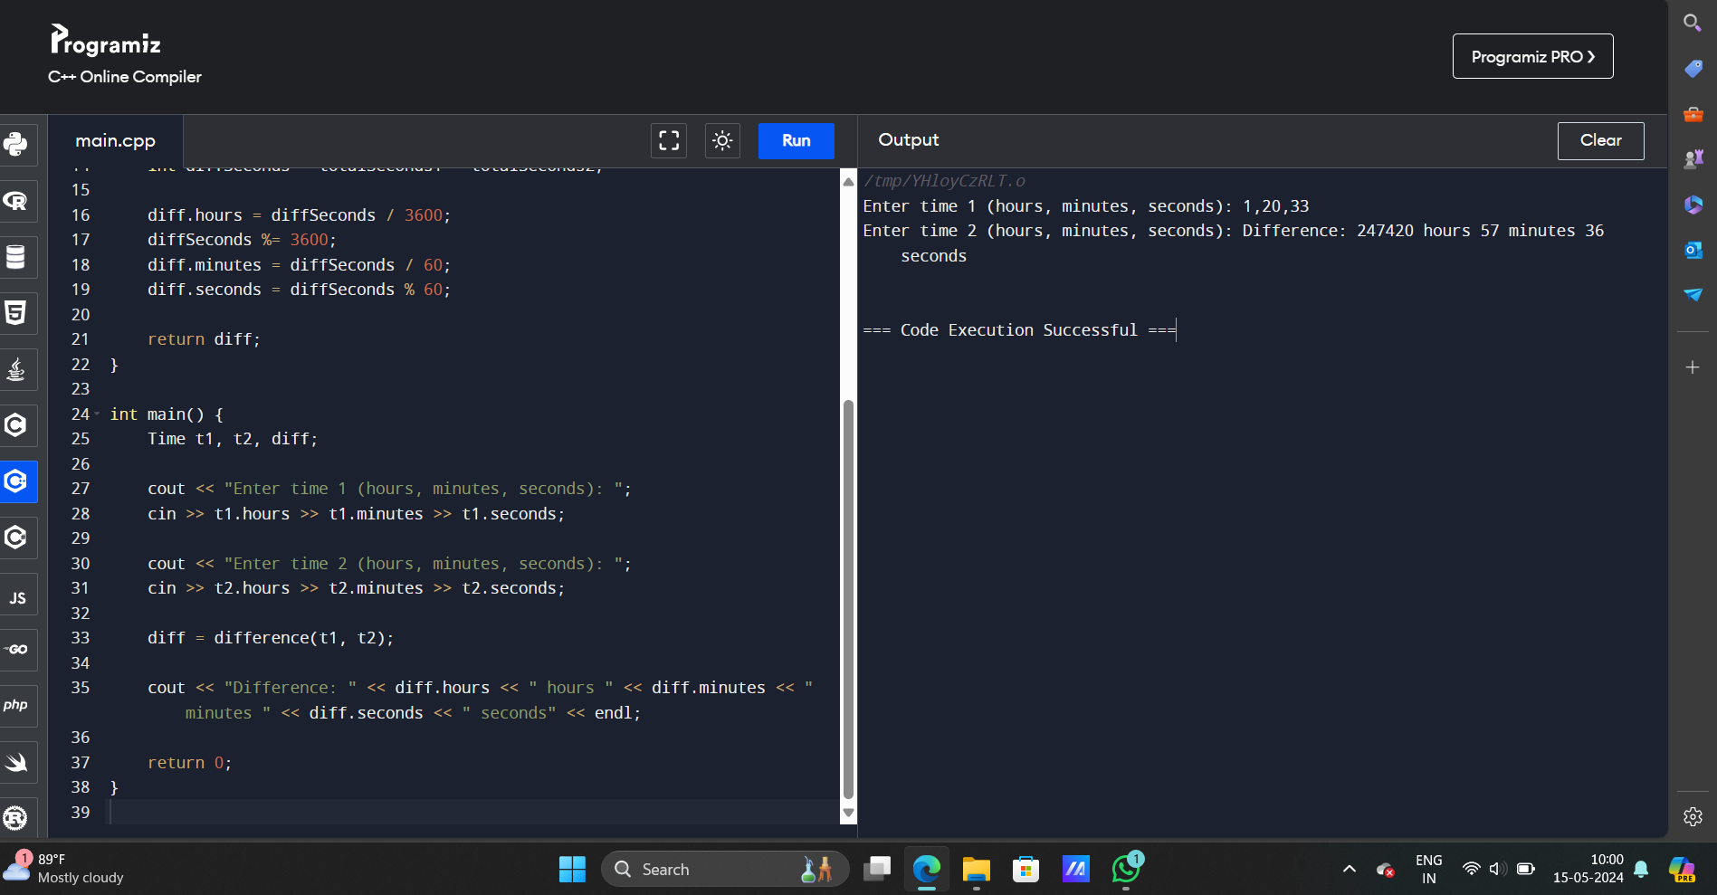

41. Write a C++ Program to Store and Display Information Using Structure

